AWS Part 2, Labs 4-6

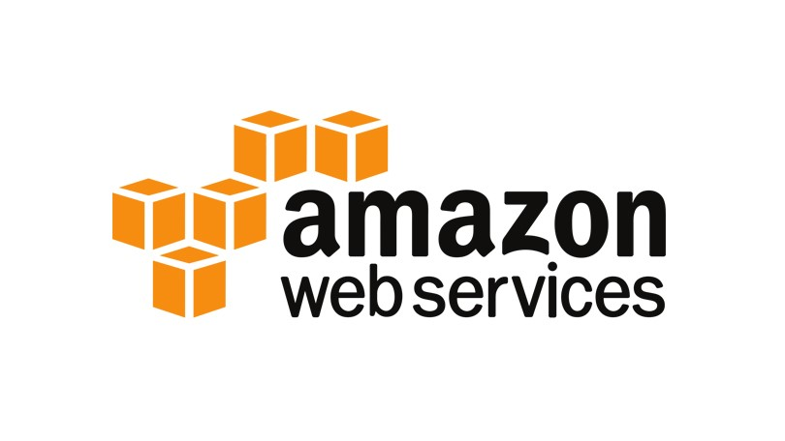

The purpose of this lab, like the last one, was to teach us how to use AWS. This shows us how to make virtual servers and other software. In the last lab, we learned how to use AWS as well as set up a VPC and EC2. This time, we set up EBS, a database server, and scaling/load balancing the architecture.

First, some background. This will be very similar to the last lab’s background because this lab is essentially a continuation of the last one. **A**mazon **W**eb **S**ervices is a service that provides virtual cloud computing for people who pay for the system. This system is a pay-as-you-go system, so if you are using more space, you pay more. This provides lots of advantages over having your own servers. You don’t have to make your own server room and you only pay for what you need. However, there are drawbacks, such as switching cloud service providers or occasional downtime.

One notable advantage of AWS is that you don’t need to have a massive server room. Because all the data is stored in a cloud, you don’t need to hold all of it in a server room. Thanks to this, you don’t need to spend a ton of money to expand the server room if you run out of space, nor do you have to worry about spending money on a bunch of servers that you will never use. Cloud computing also is more secure. You don’t have to worry about having someone break into the room and gather sensitive information, so you can also spend less money on security for resistant locks and security cameras. Best of all, you also don’t need to spend any money on maintenance for your server room or anything. AWS handles all that for you.

Cloud computing services like AWS follow a pay-as-you-go system. This means that if you use more data, you pay more money. This is a dynamic payment system that works great for businesses. They end up just paying for however much data is being used, which is predictable. All you have to do to determine the cost of your service is to go to this website (<https://calculator.aws/#/>), tell it what services you want to use and how much data is expected to be consumed while your virtual servers are running, and it will automatically calculate the cost of the type of data and how much you are expected to pay per month.

However, cloud computing services like AWS have their drawbacks. One problem is that cloud services may have downtime. This is obviously a problem when businesses are trying to get their data, but the cloud service is down. If the business can’t get its data from AWS, especially in critical situations, the business may have to be suspended for a while until the servers are back up. They may not be able to get the change out in time and could lose money. Also, switching from one cloud service to another can be a nightmare. If someone wanted to switch from AWS to something like Microsoft Azure, migrating all the data and setting up everything again can be a huge pain. This could result in using both services charging them until all their data is eventually moved.

In summary, I learned about AWS’s power and usefulness, then about certain parts and their functions. I then completed 3 labs, each showing an individual piece of AWS.

Here are the "commands” that I used to complete this lab. These will all be pictures of the instructions because the labs were just following the instructions. This is also like the diagram. Normally, I would use a premade drawing of the labs. However, I don’t exactly have the ability to show the AWS servers, so the instructions will be close enough.

Lab 4

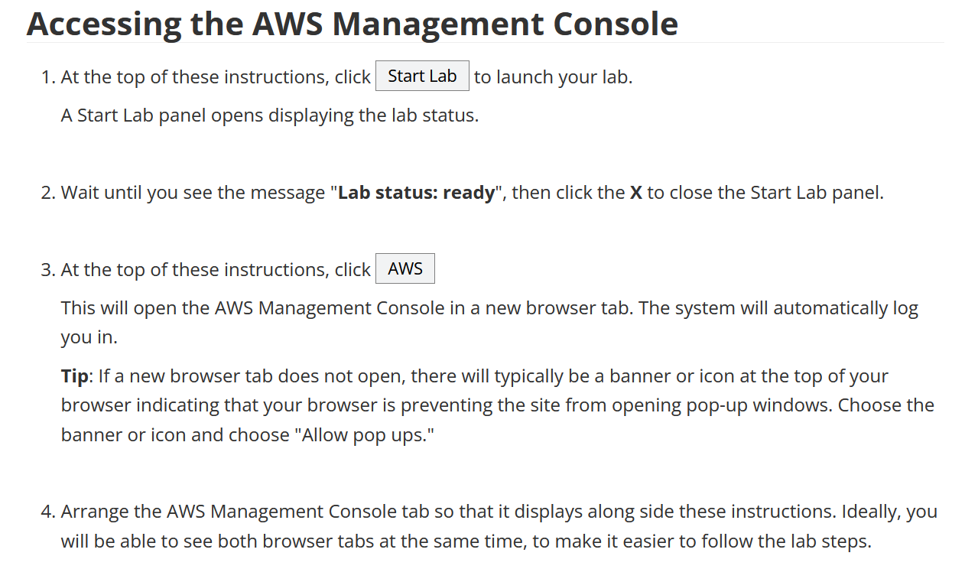

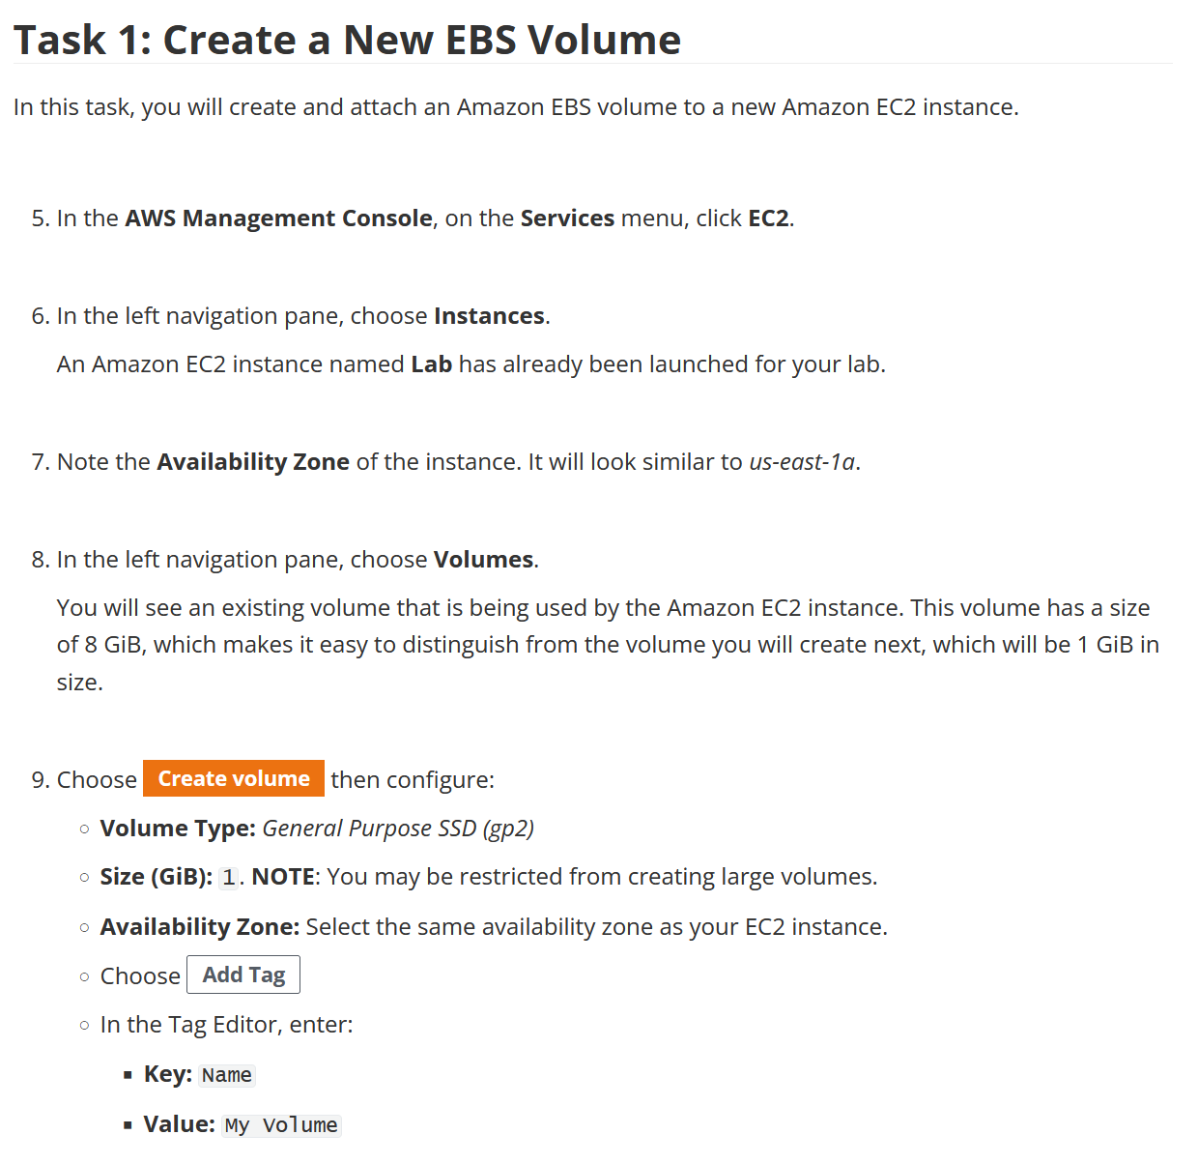

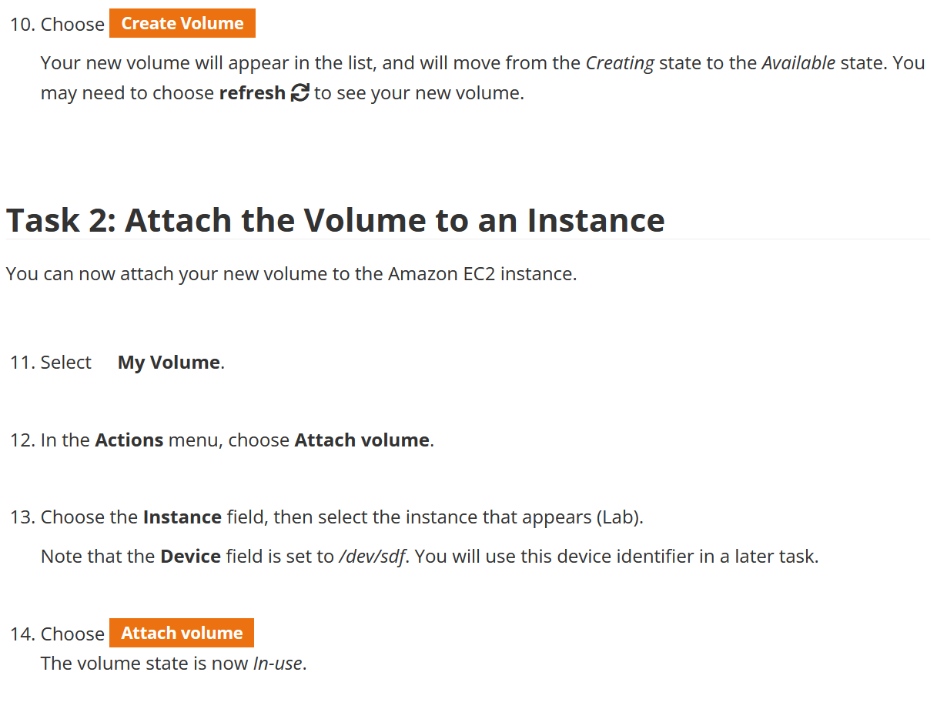

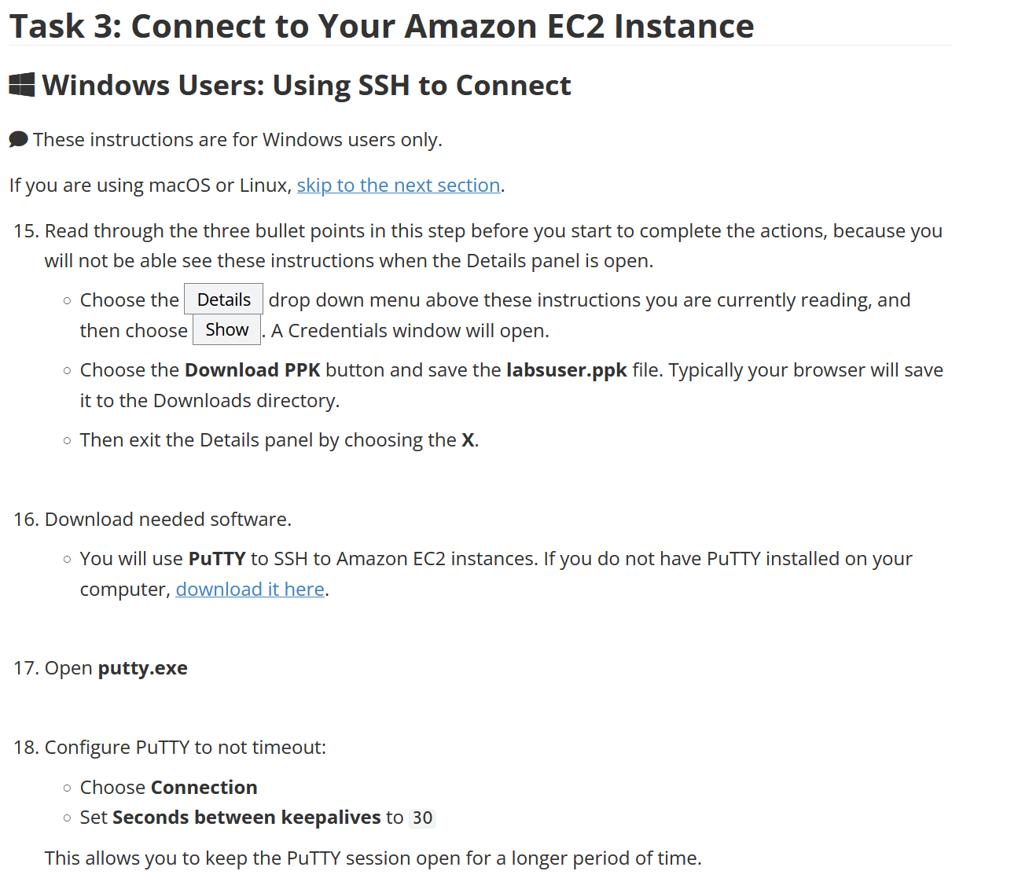

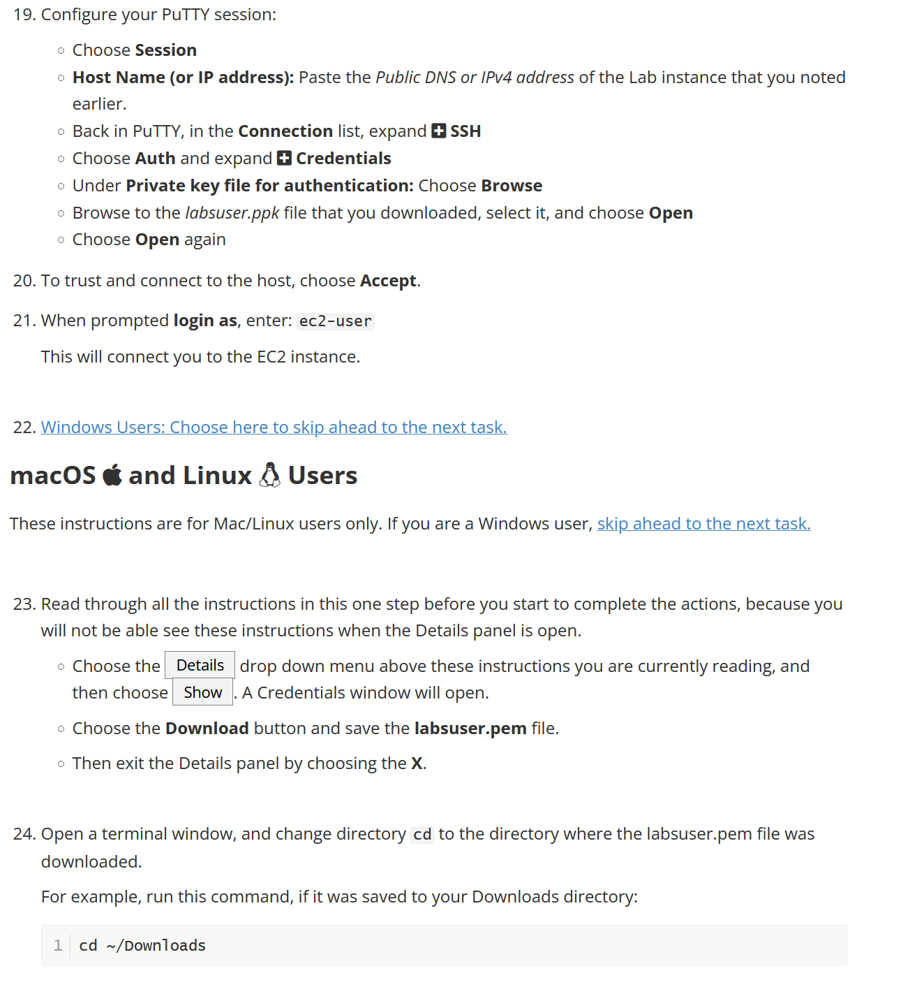

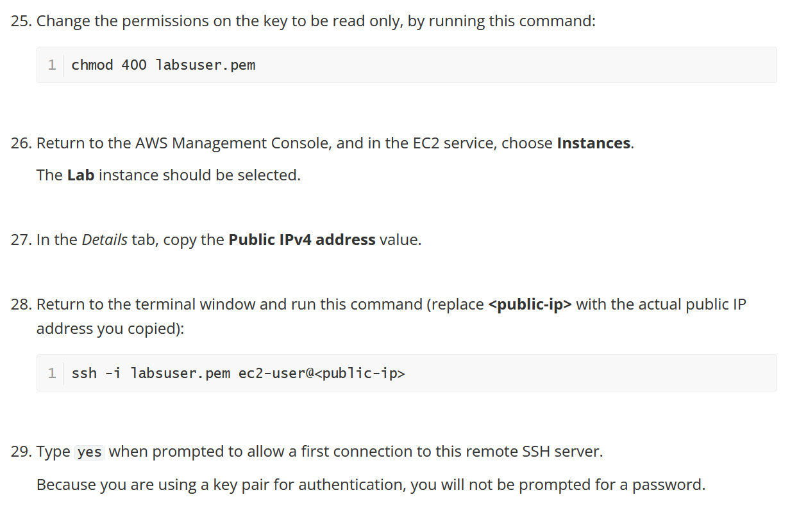

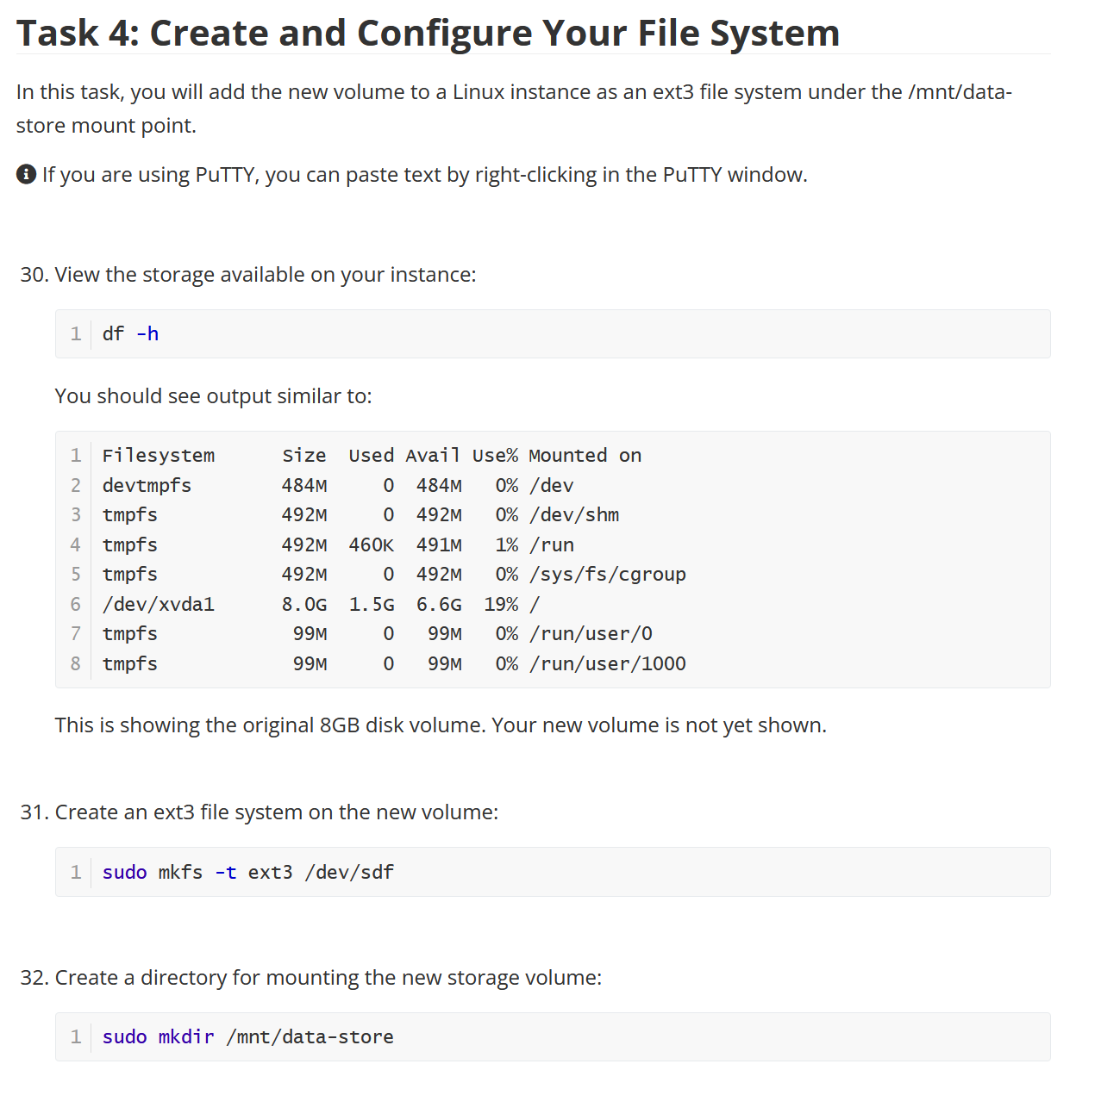

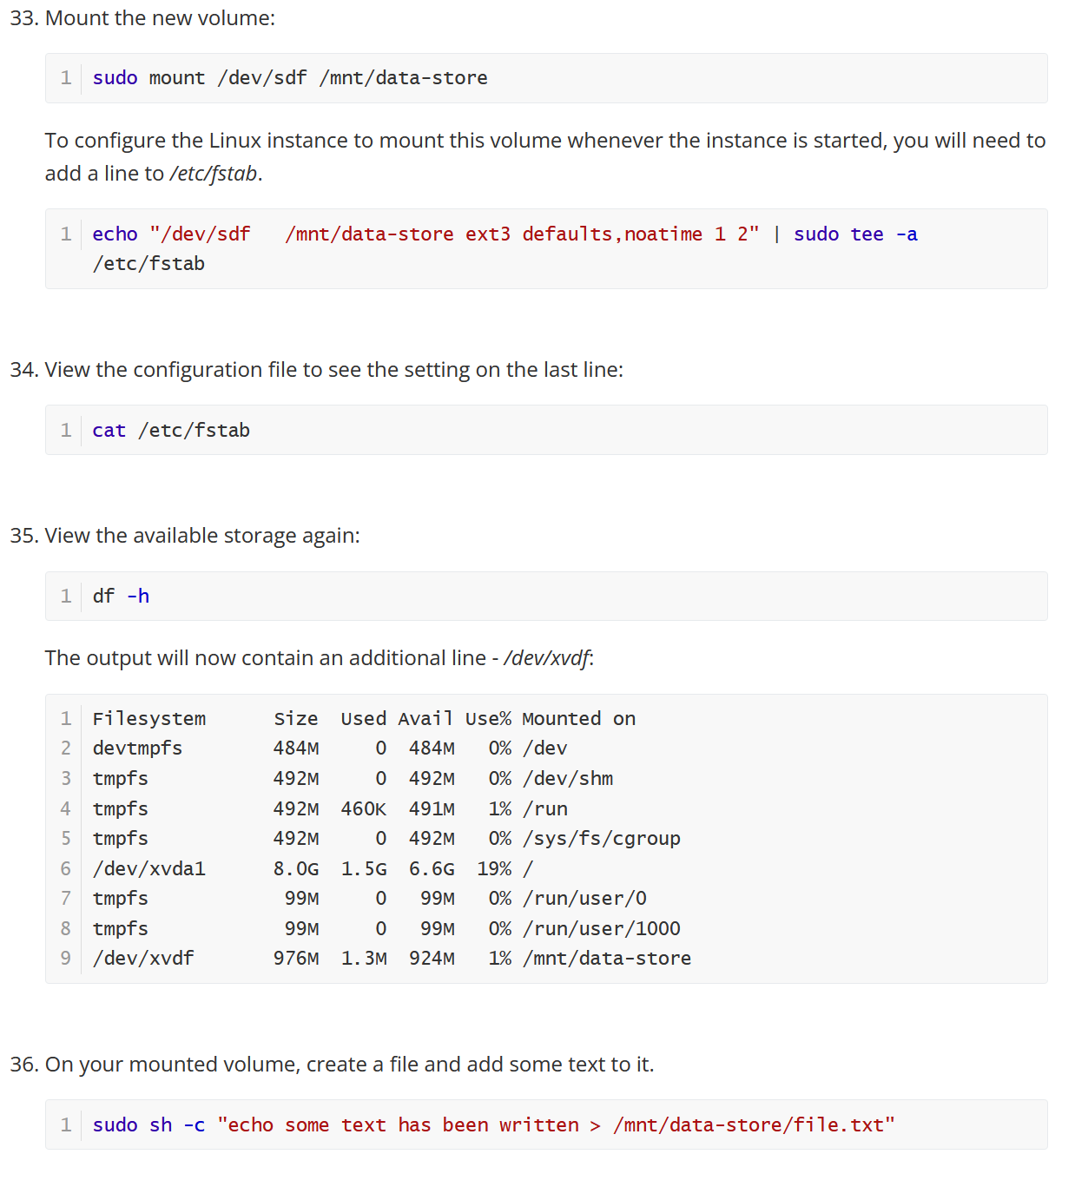

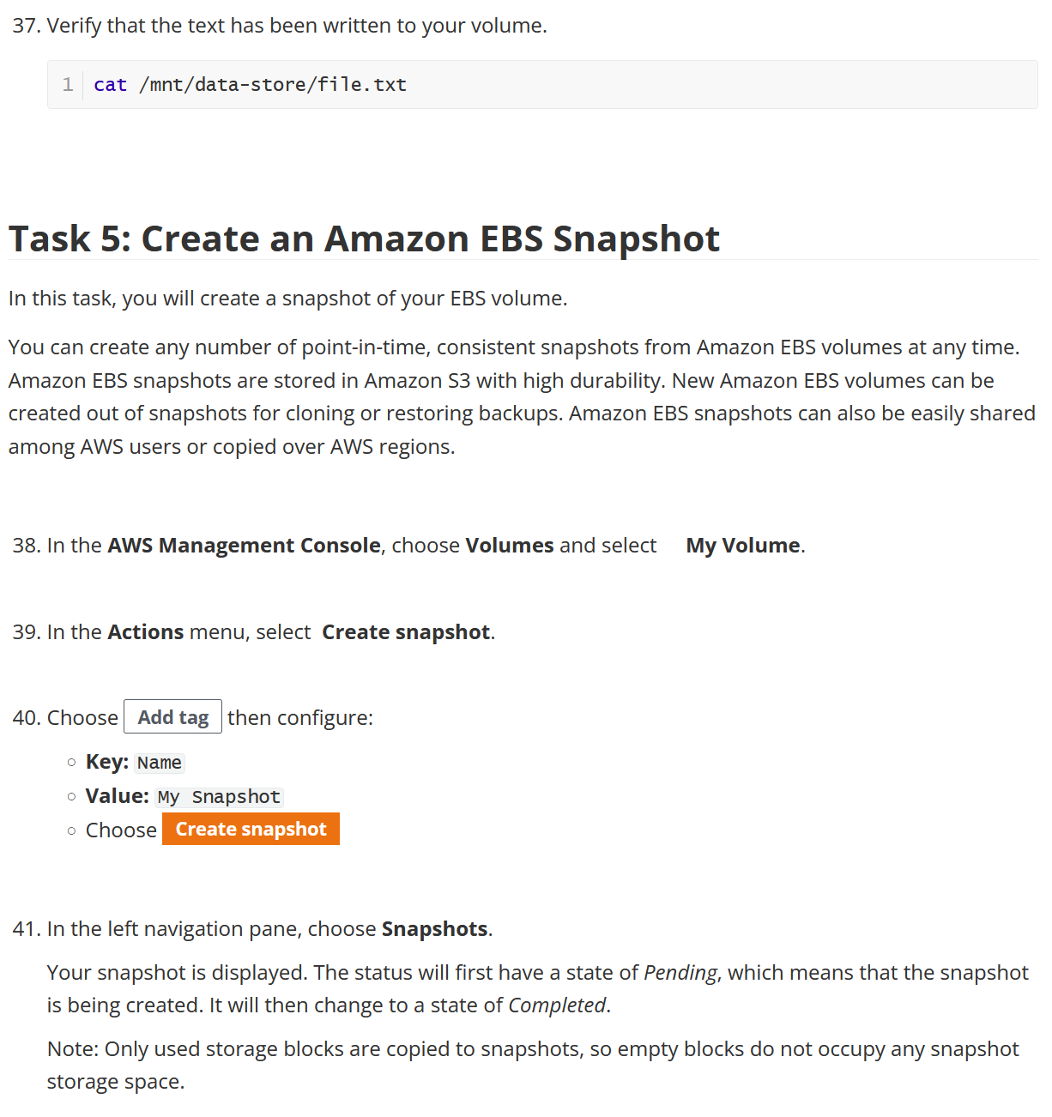

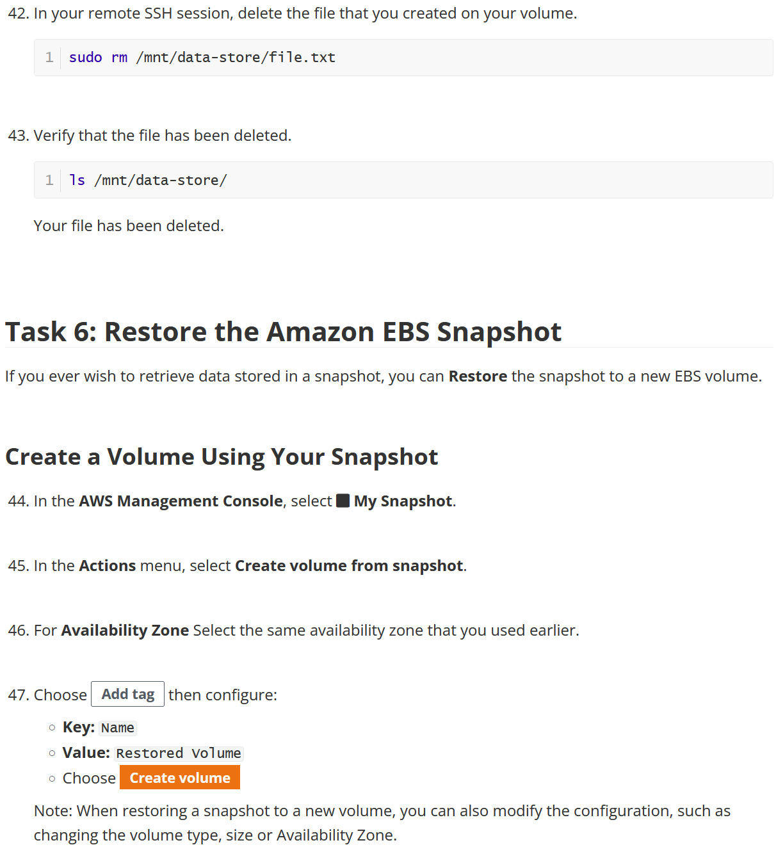

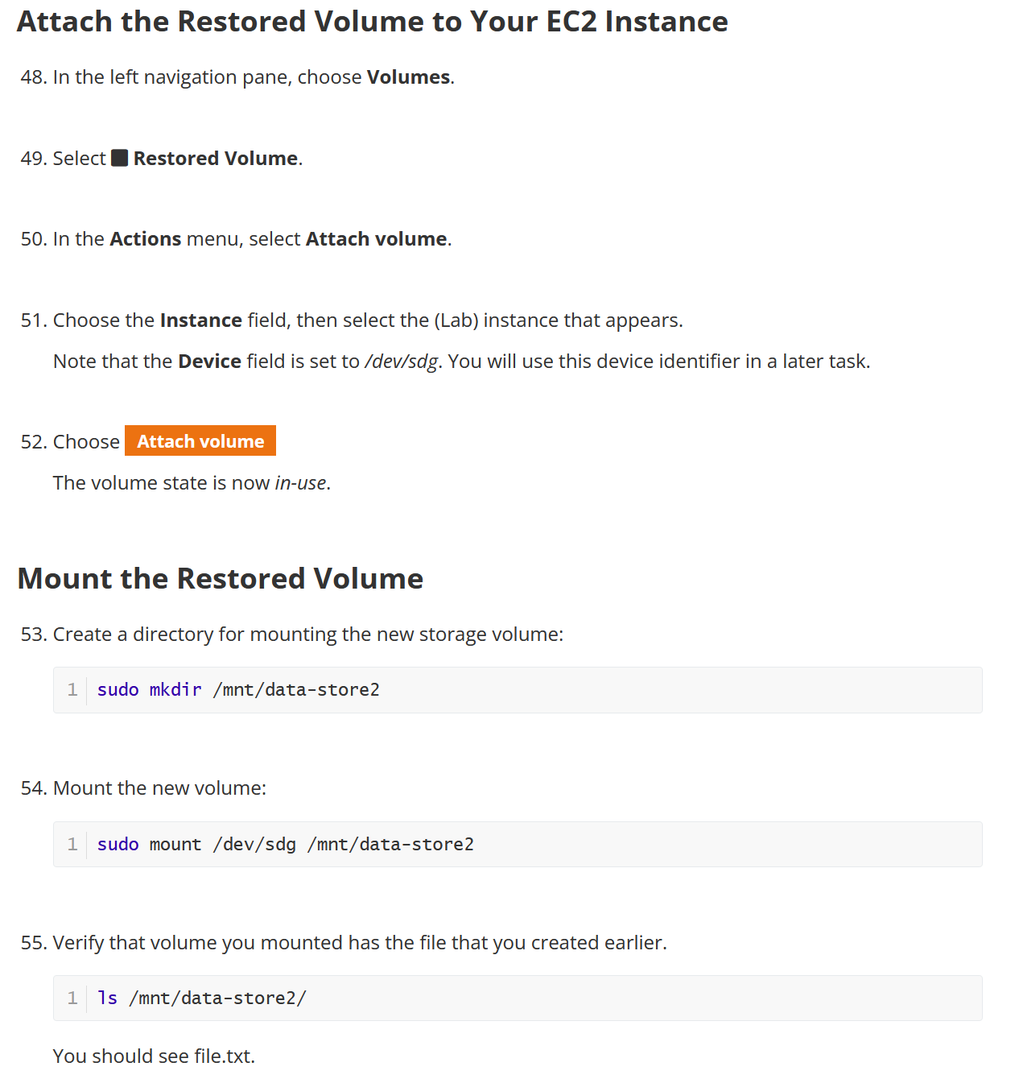

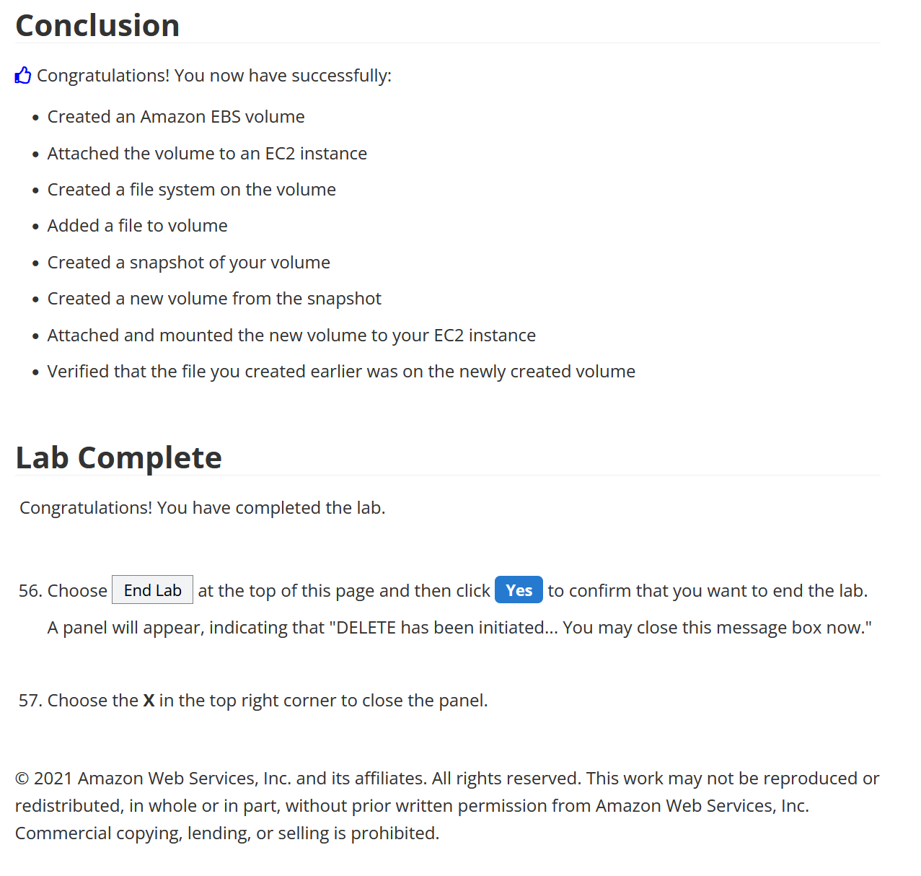

Lab 5

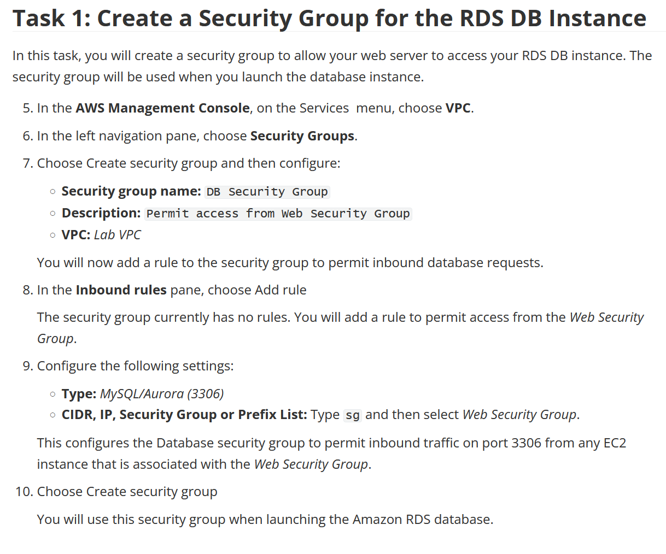

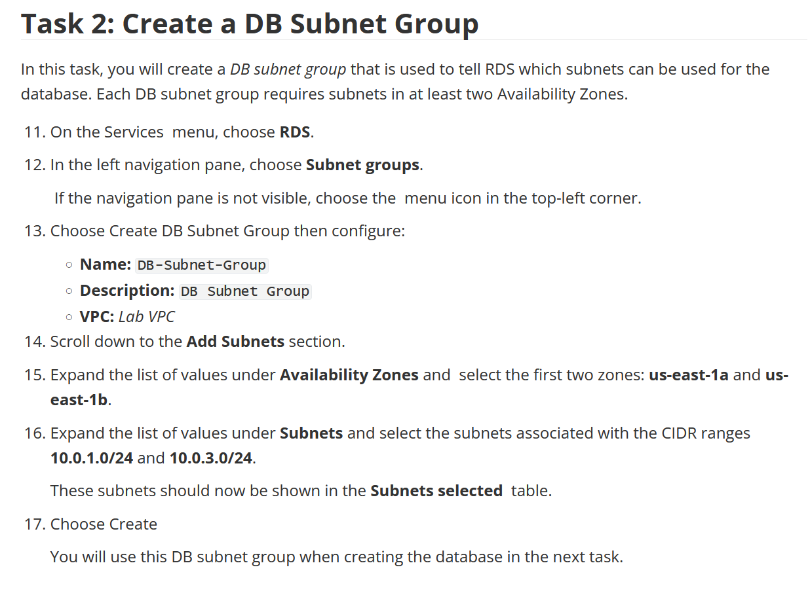

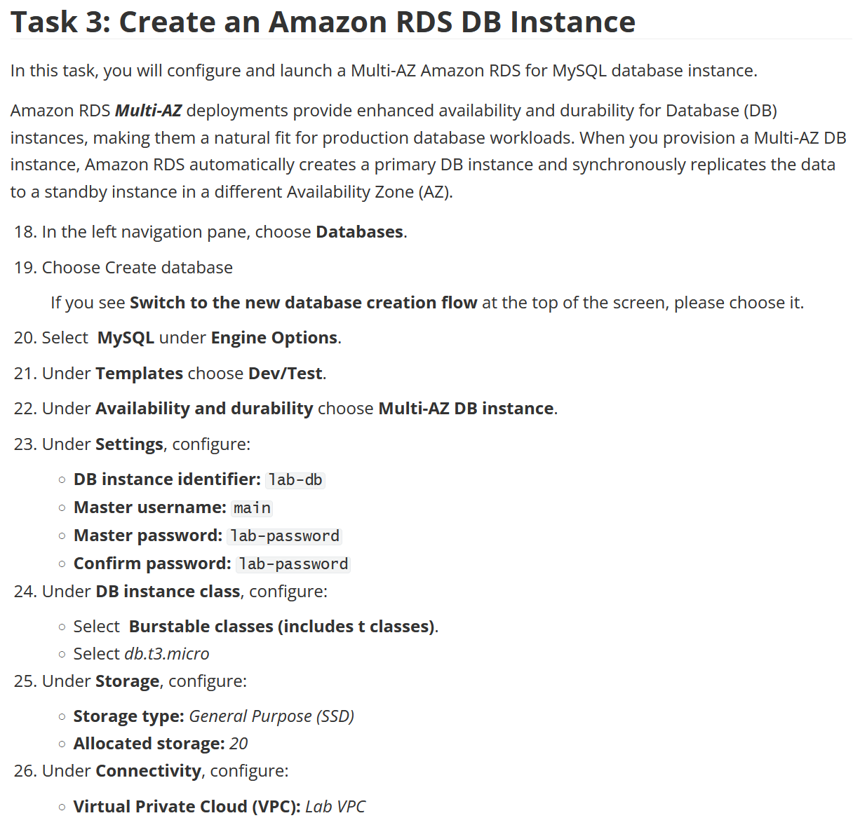

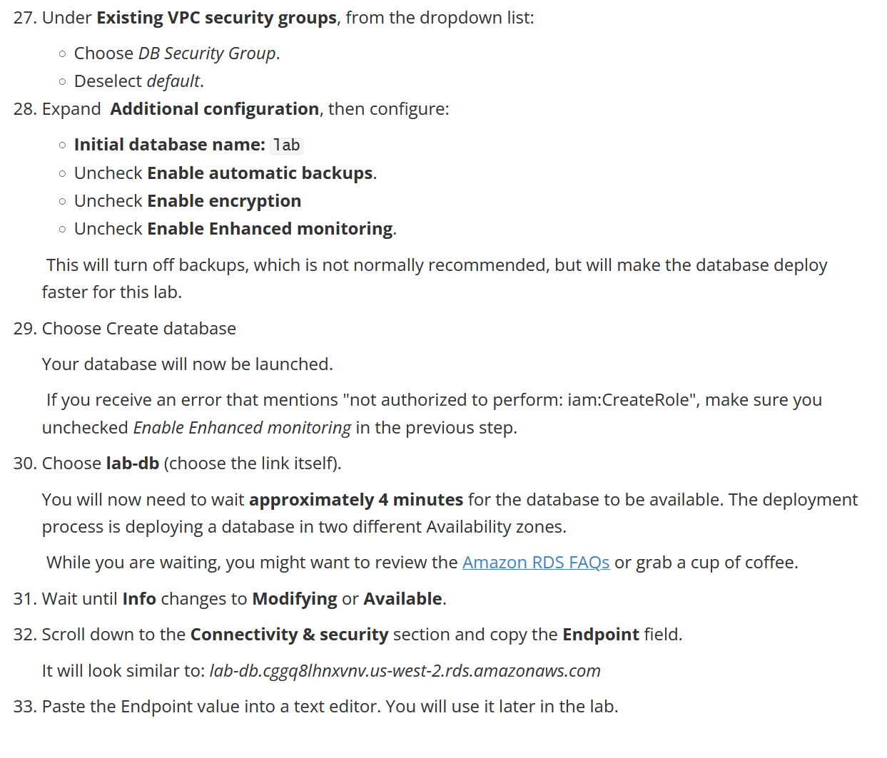

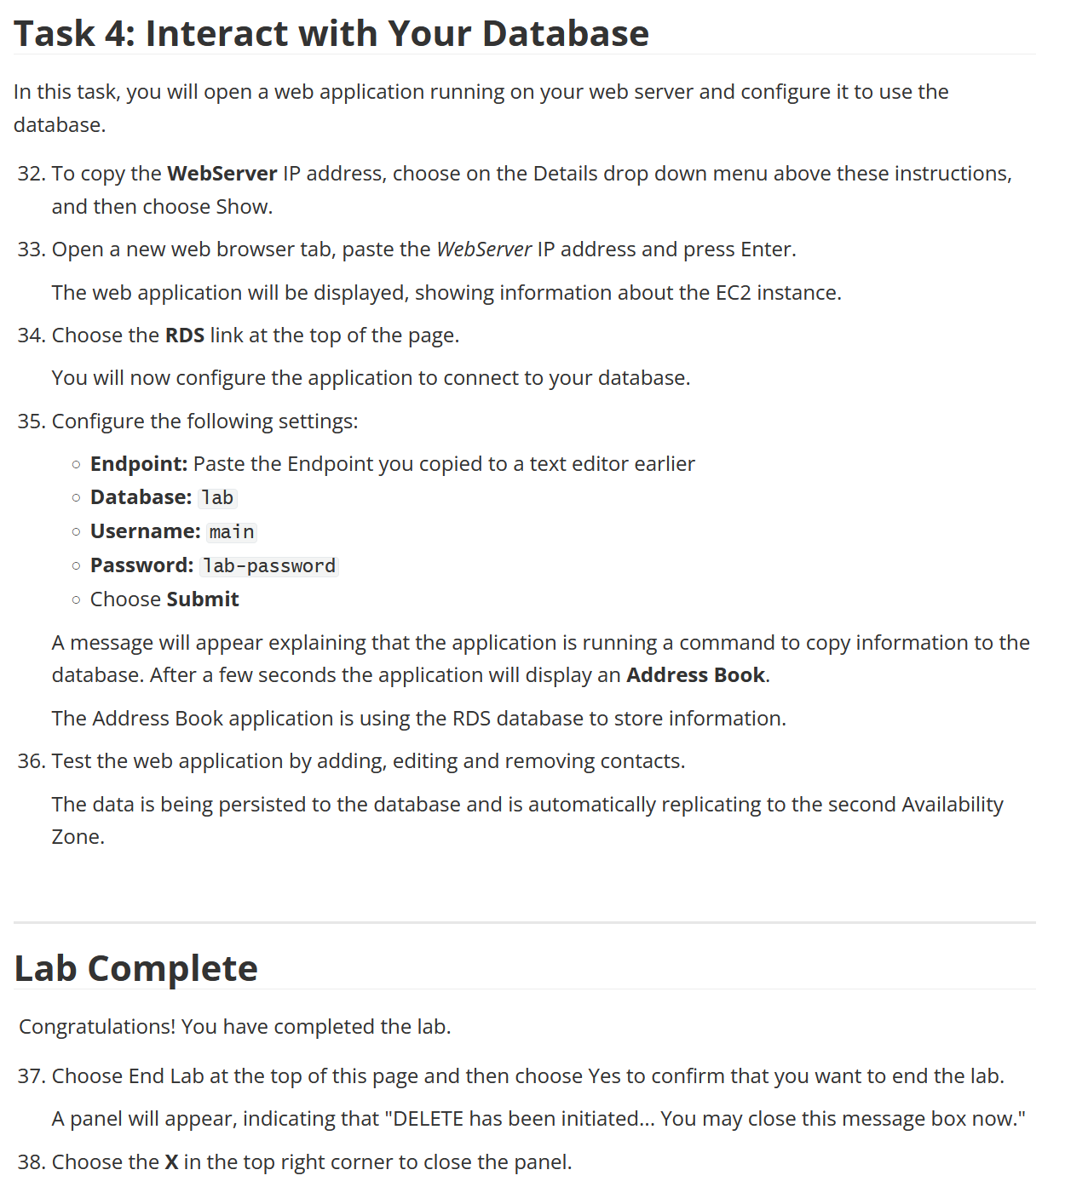

Lab 6

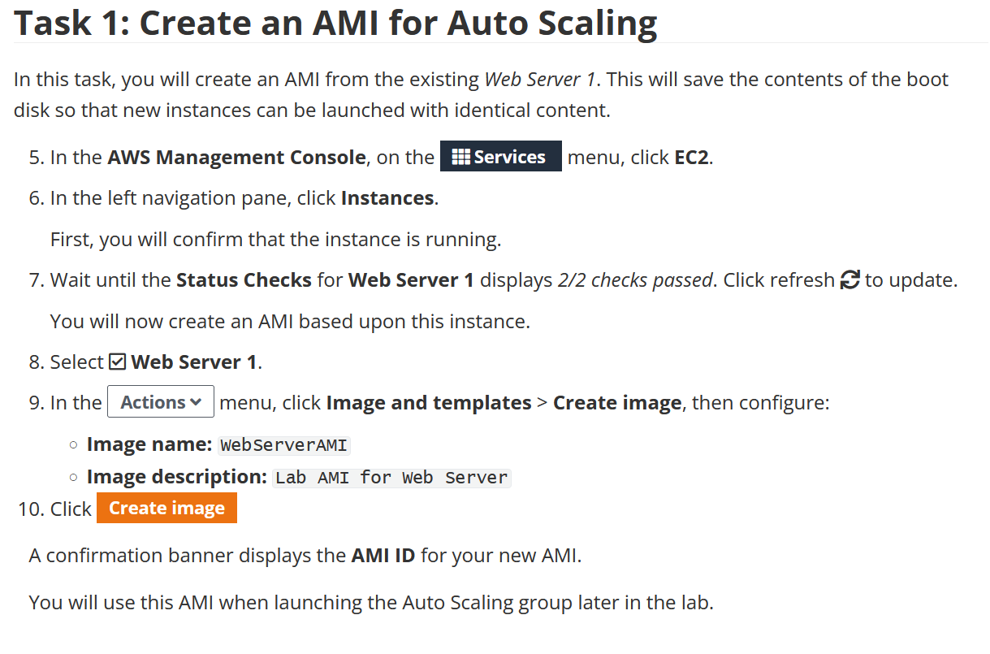

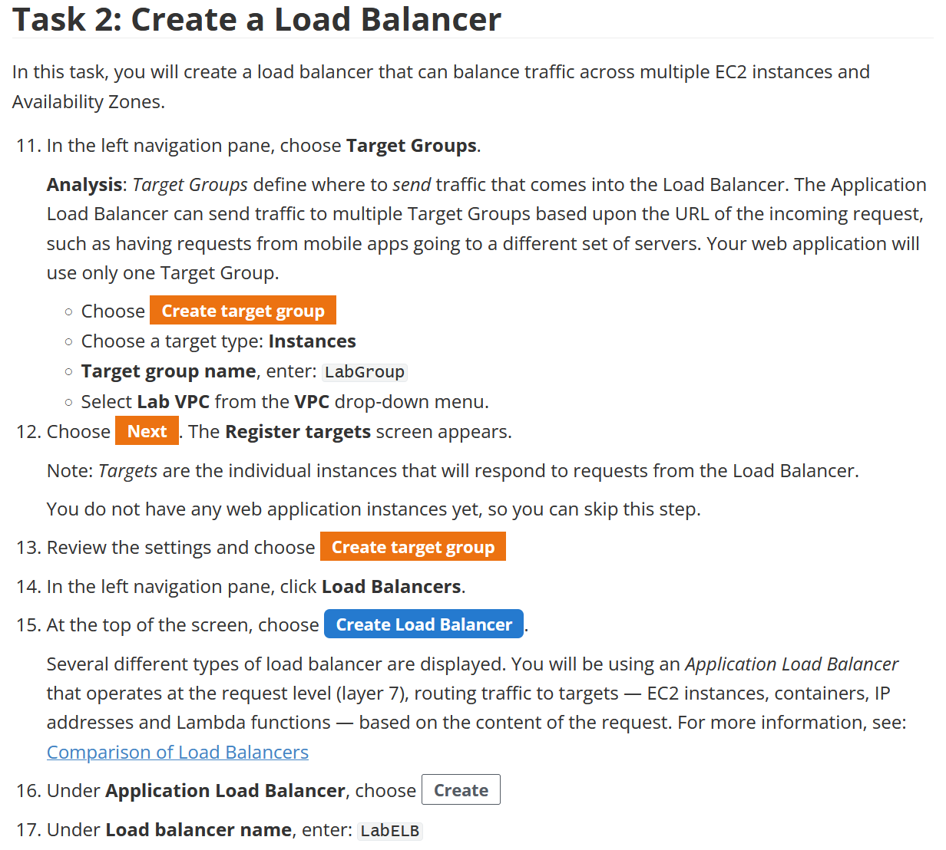

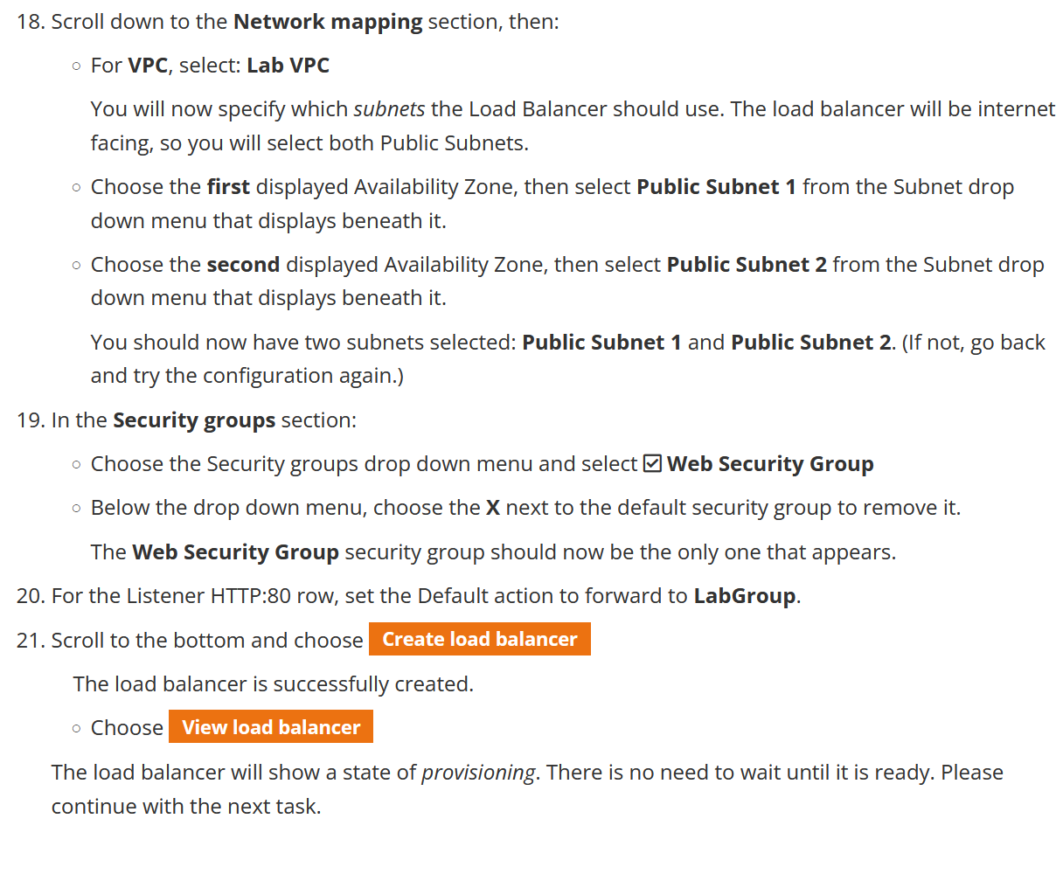

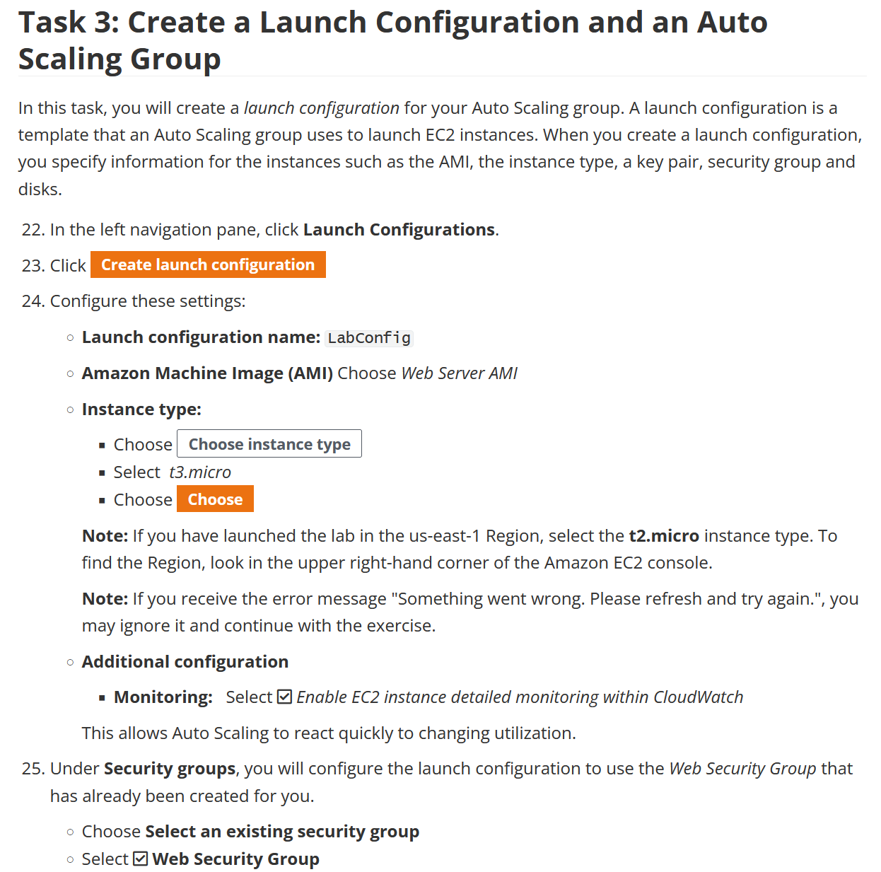

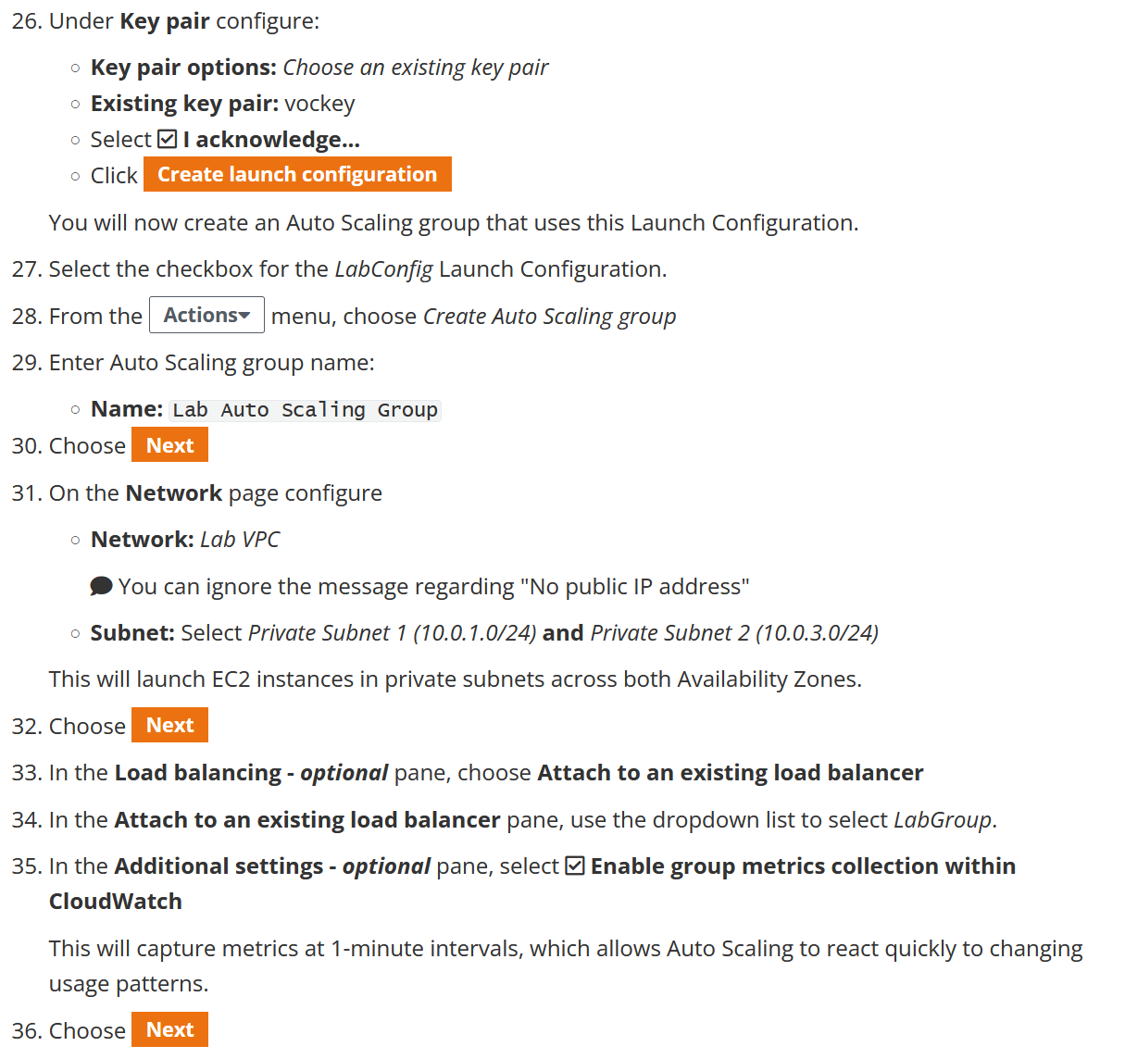

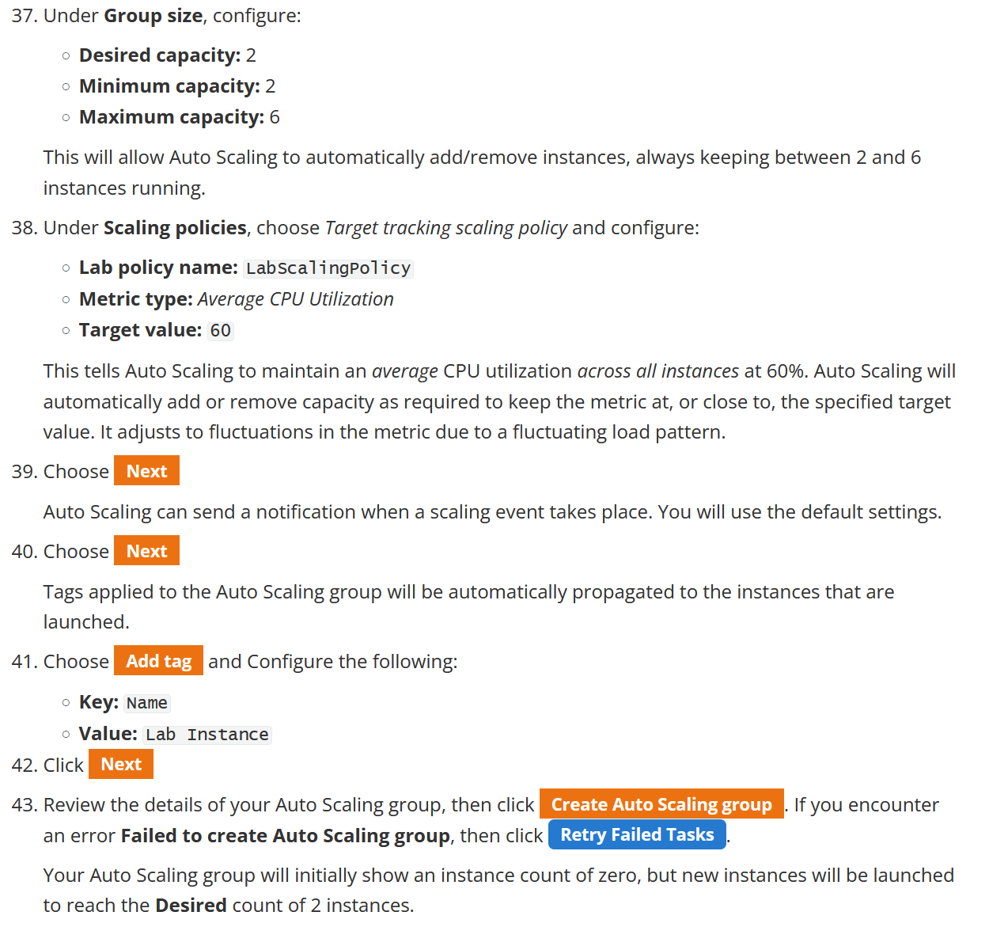

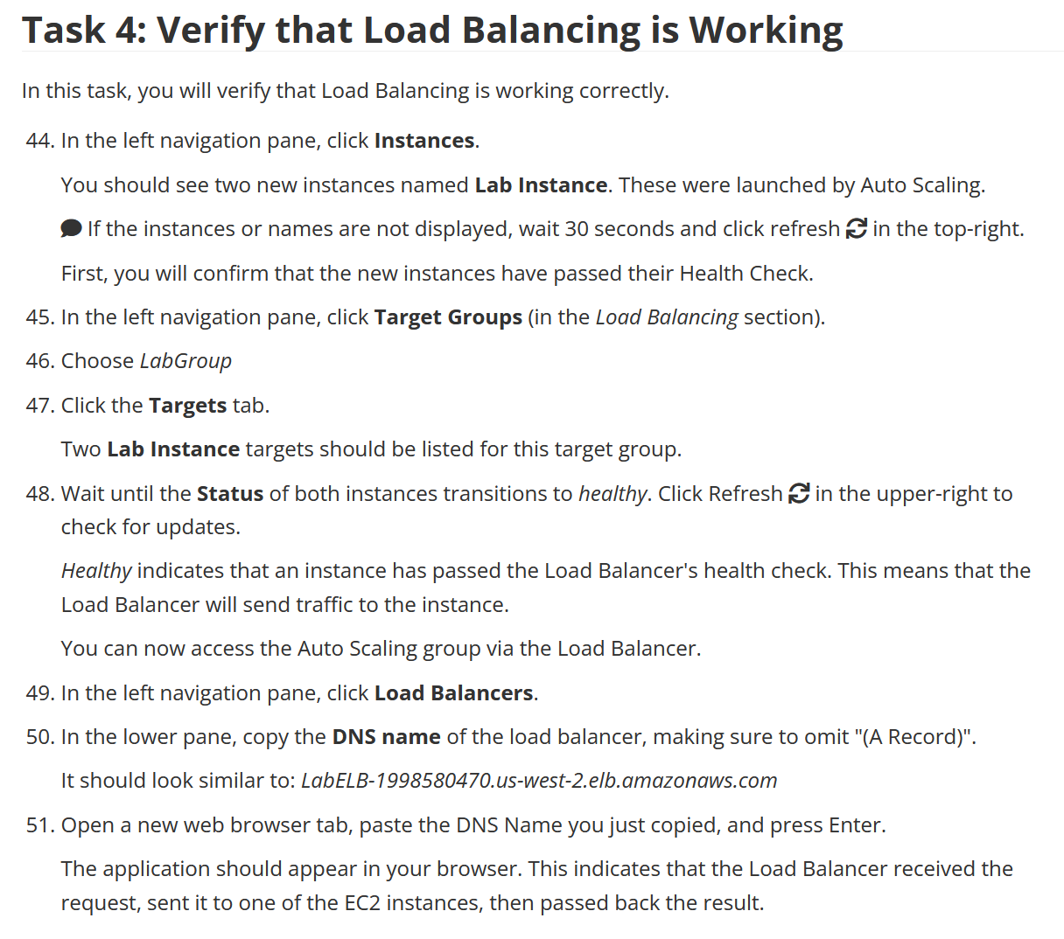

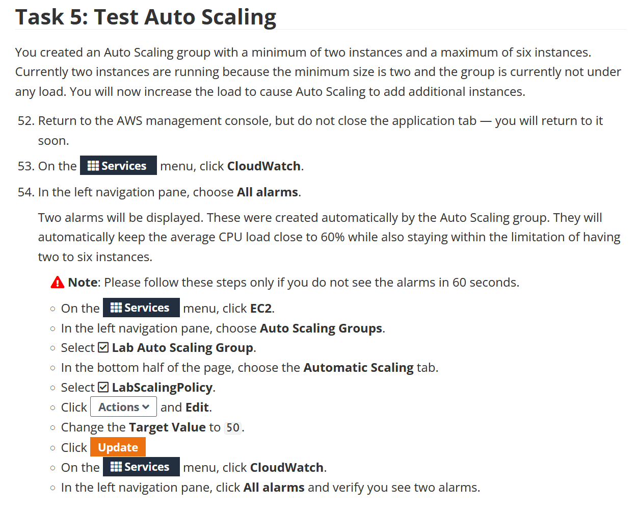

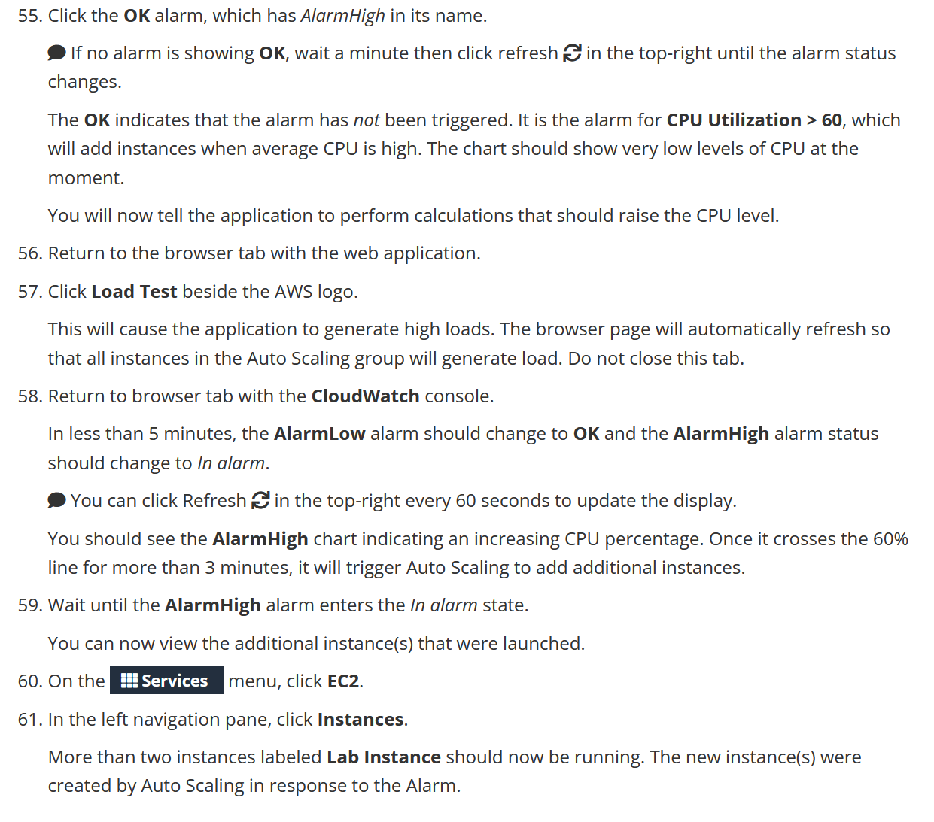

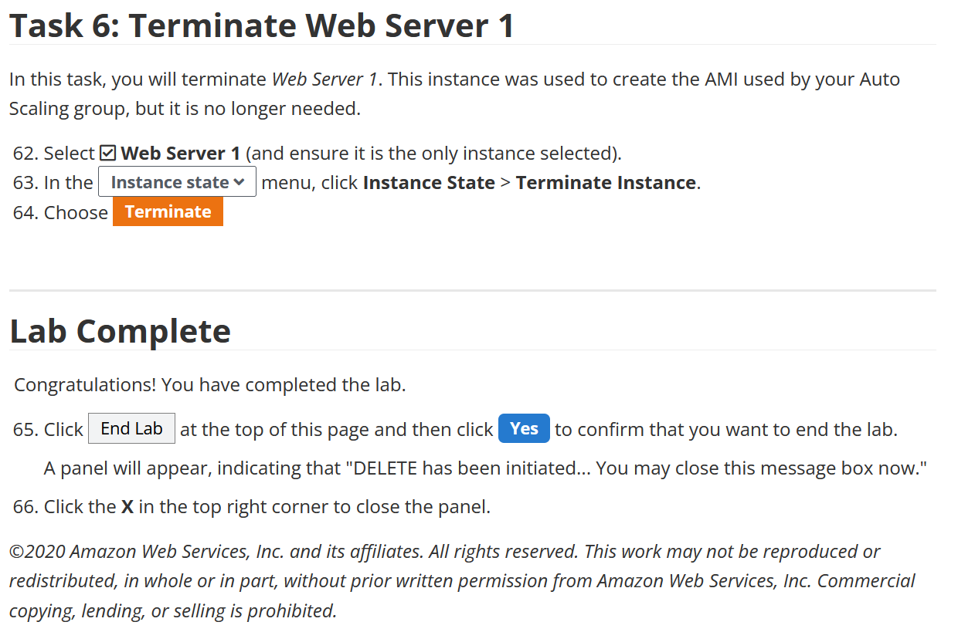

Like the last lab, all the commands I used will just be screenshots of what I did in AWS. Because there are no commands, everything I send will be more screenshots.

Lab 4

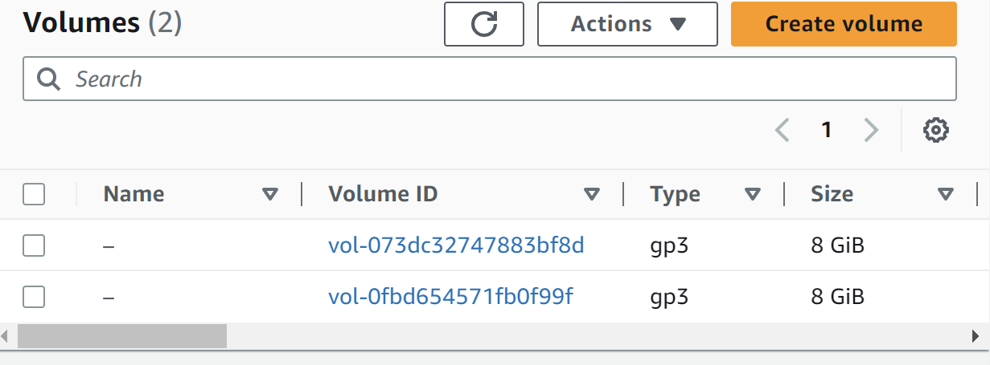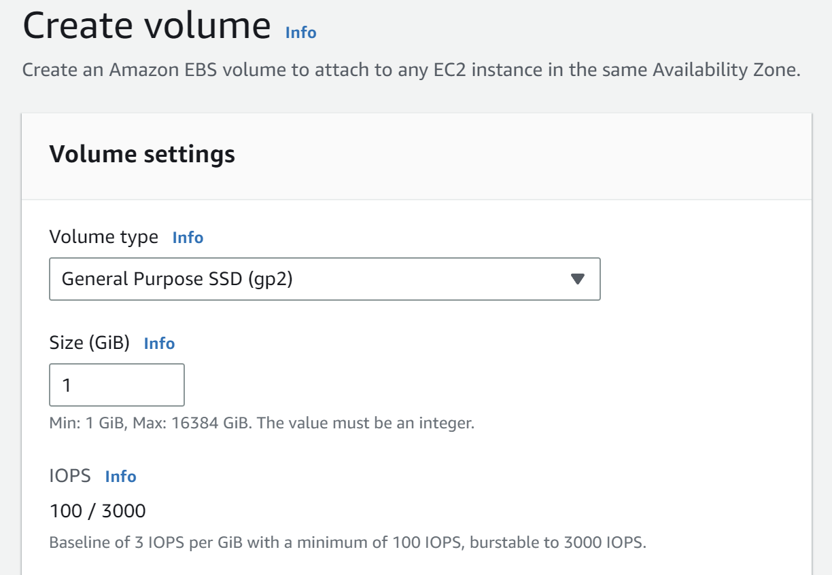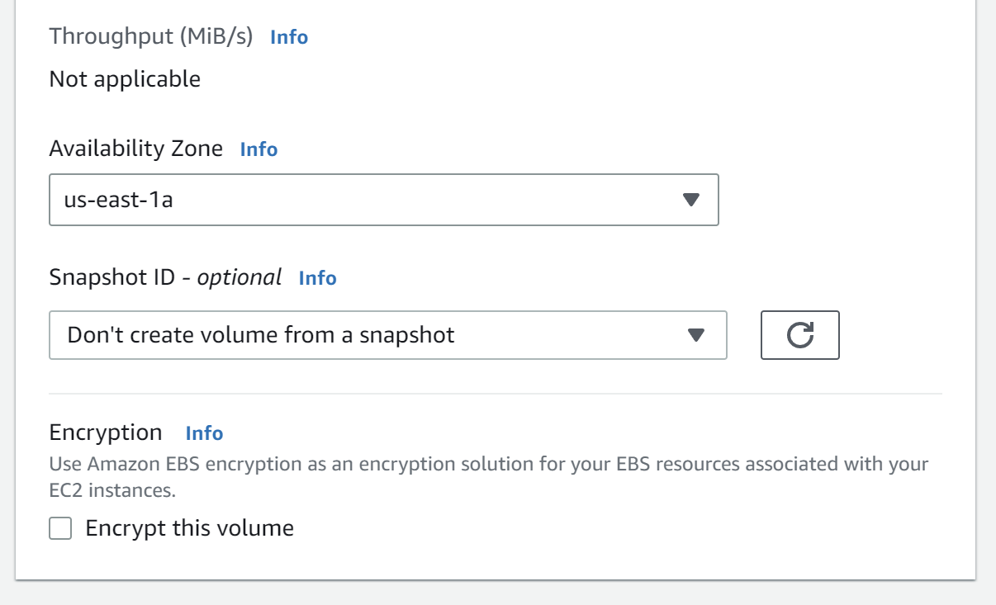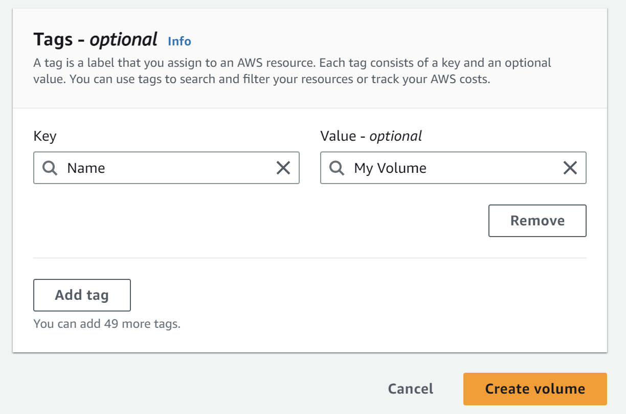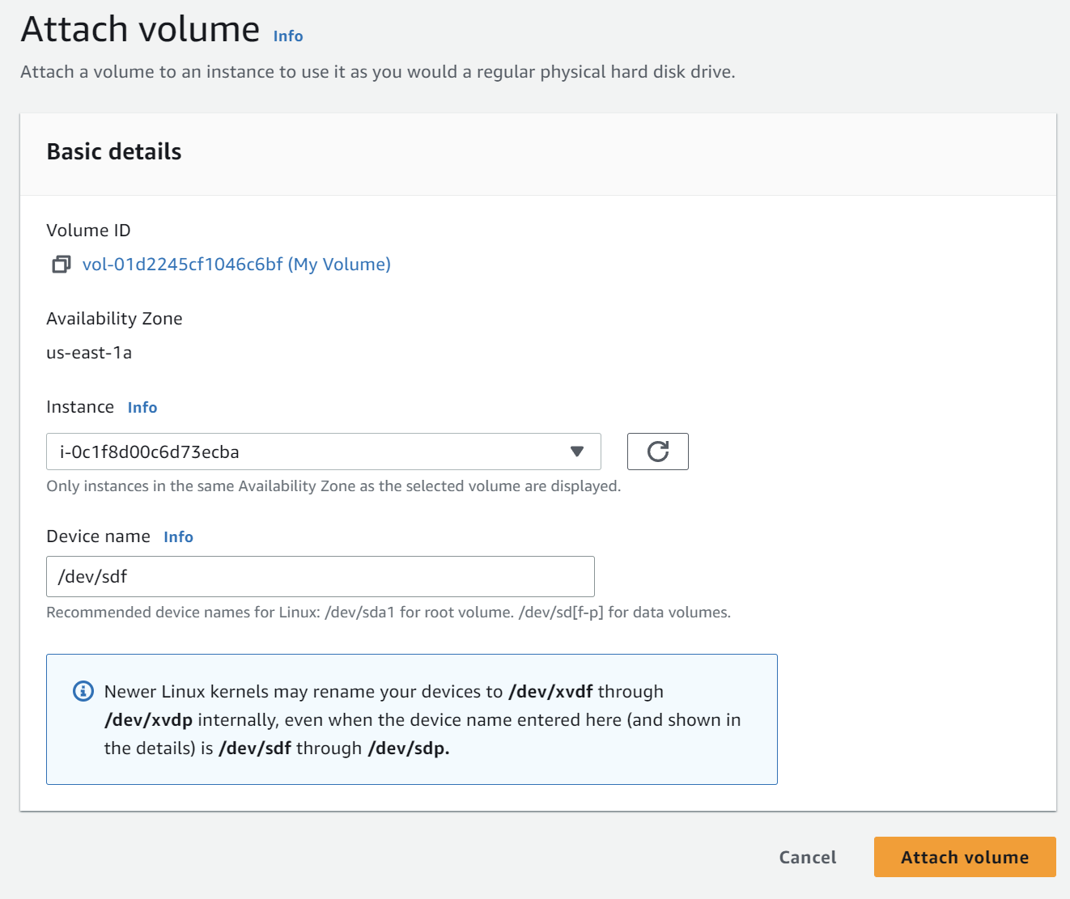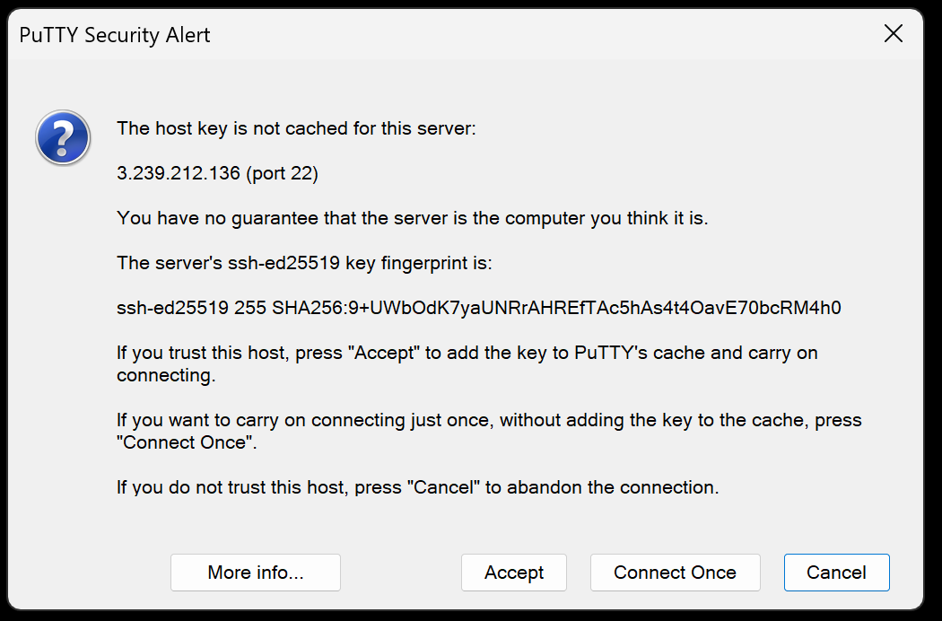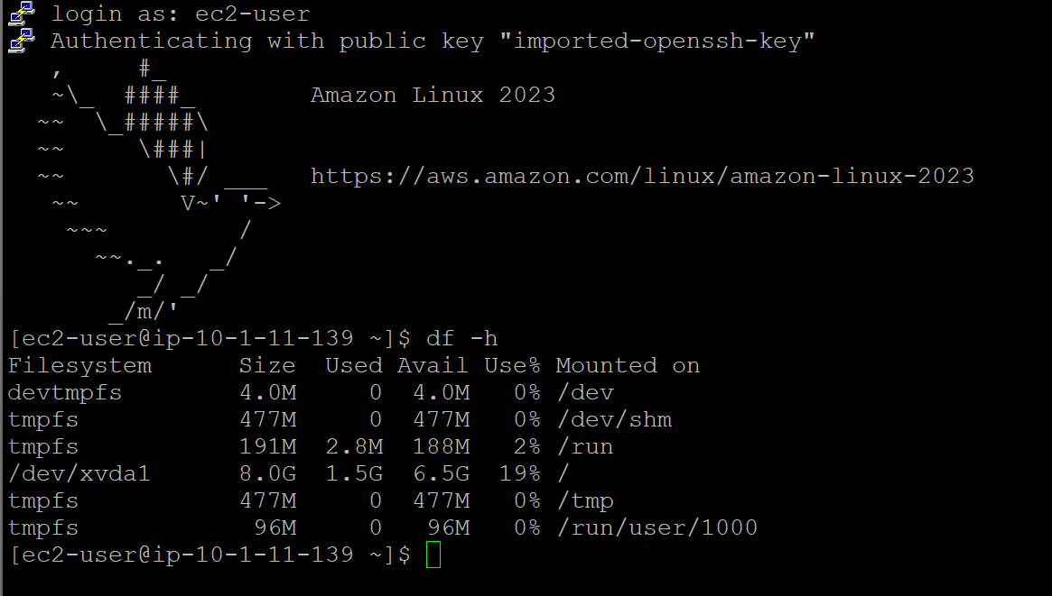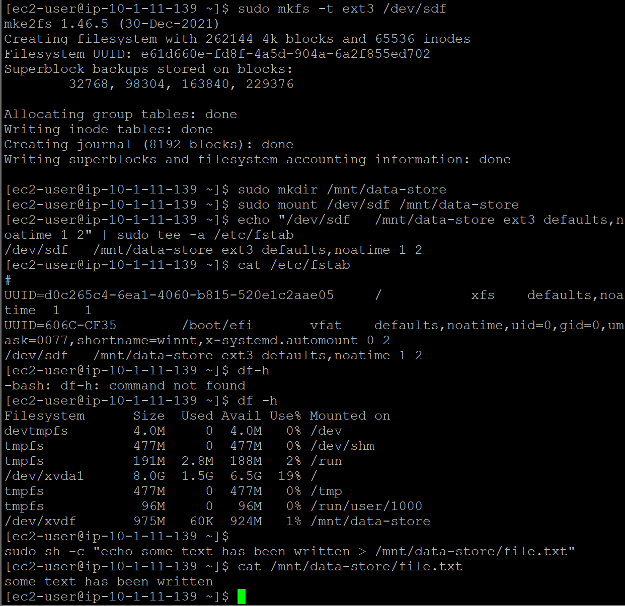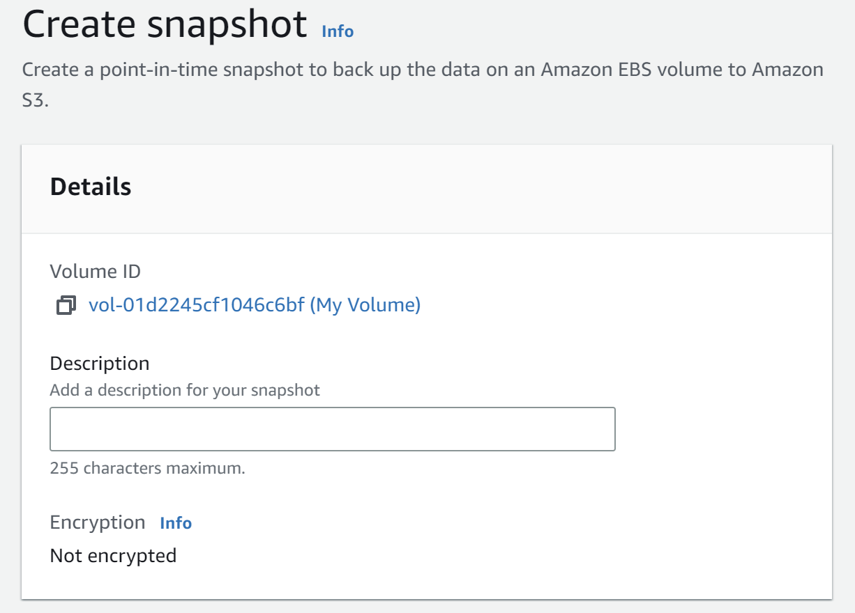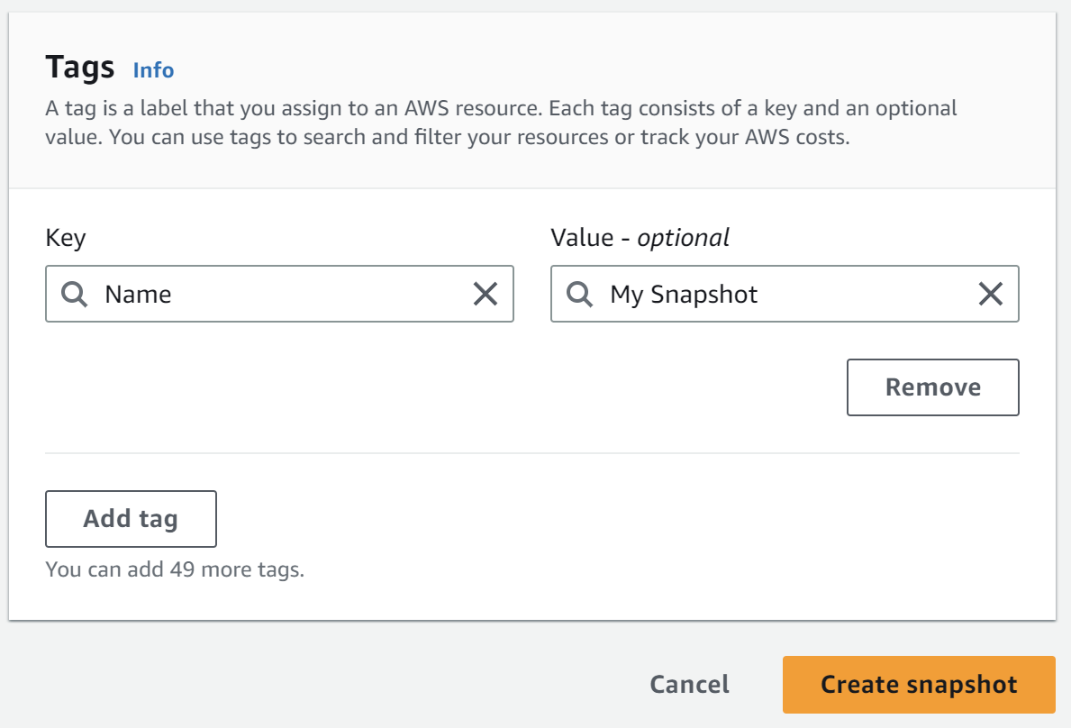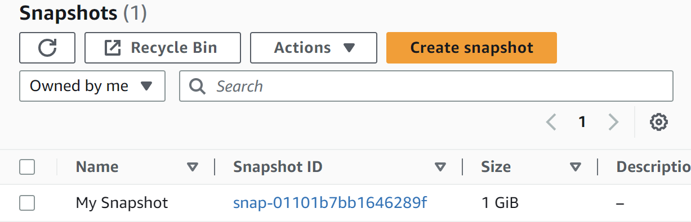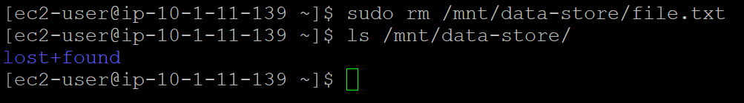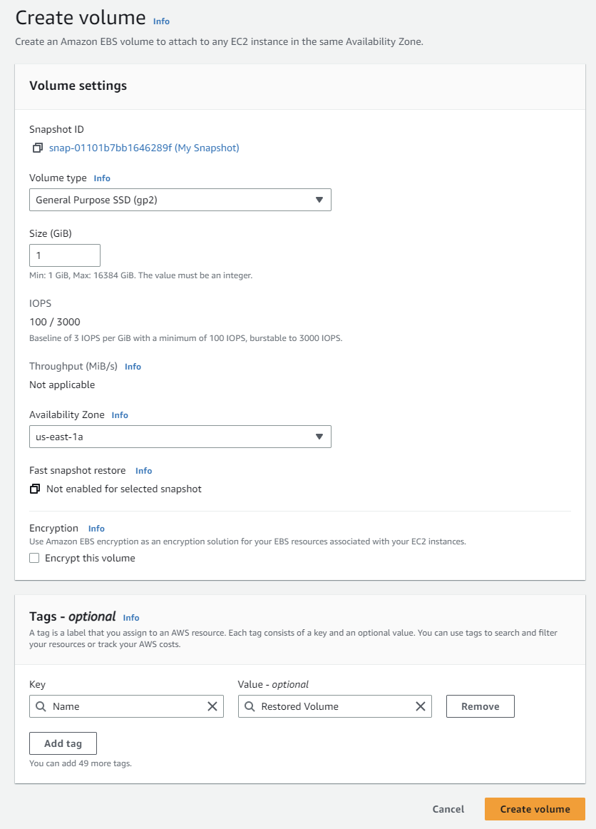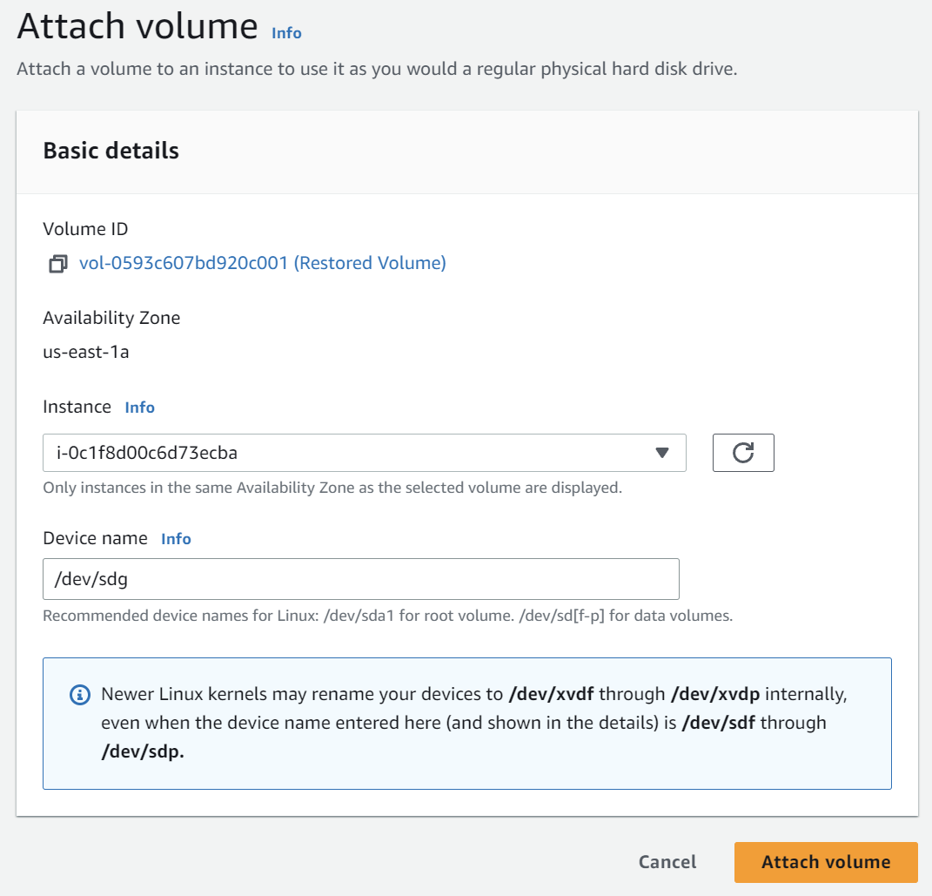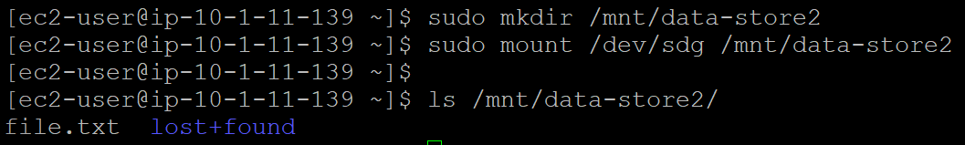

Lab 5

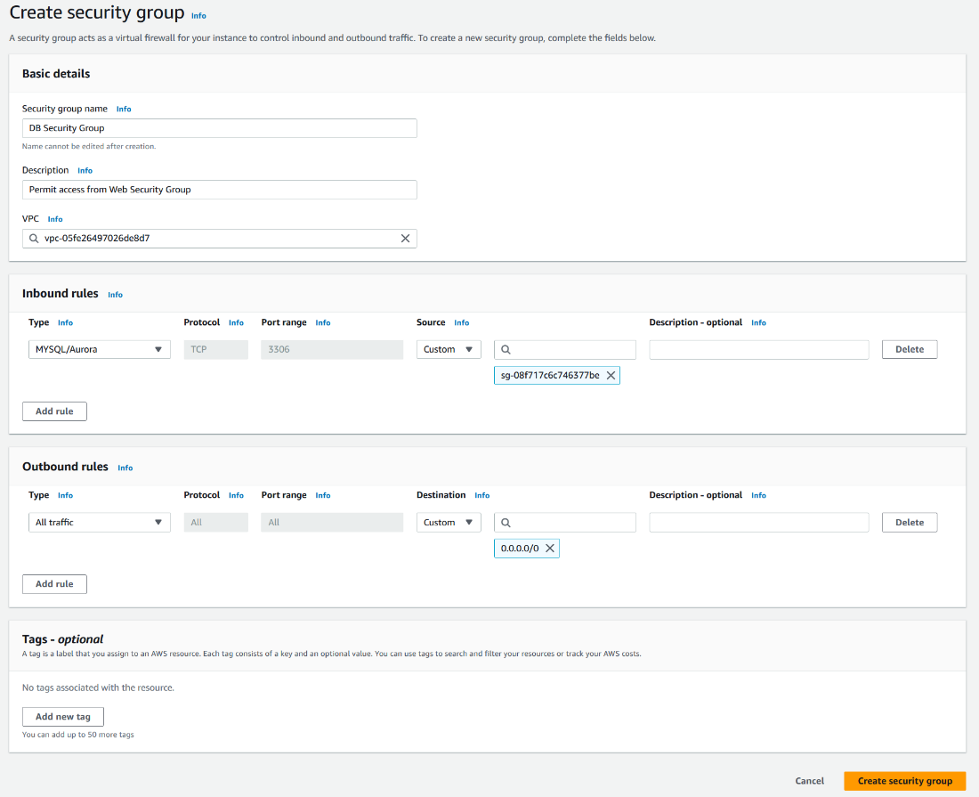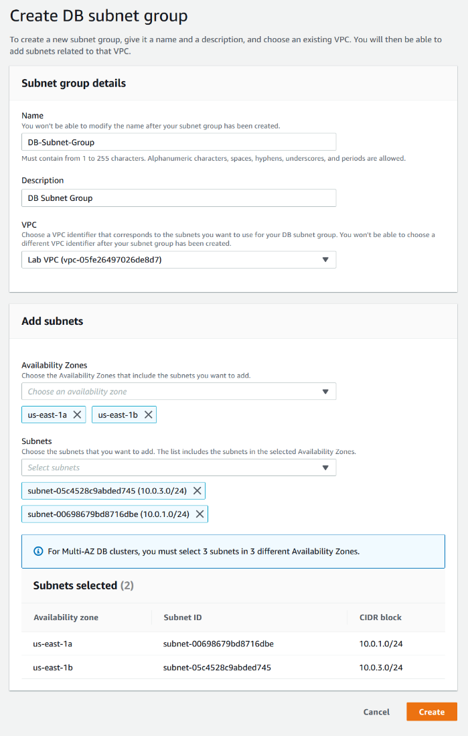

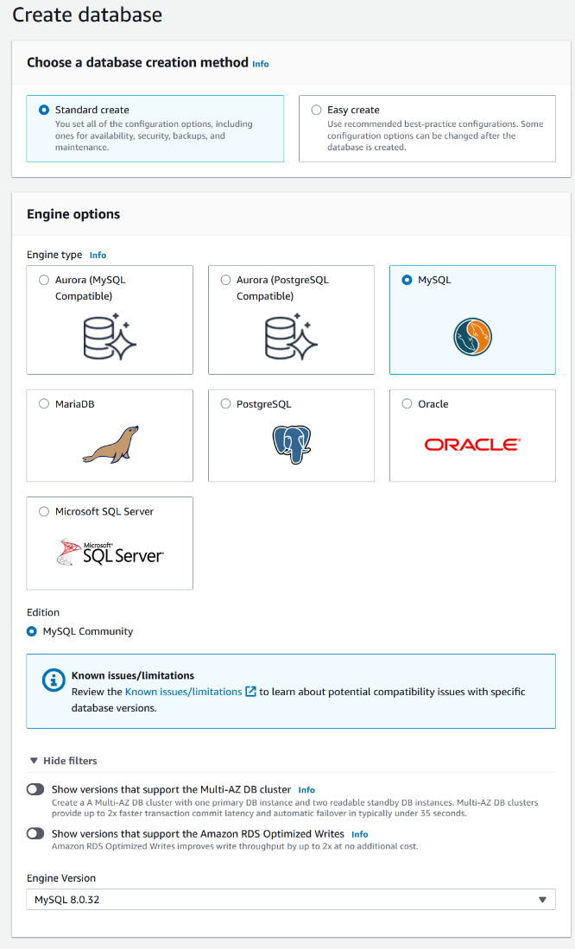

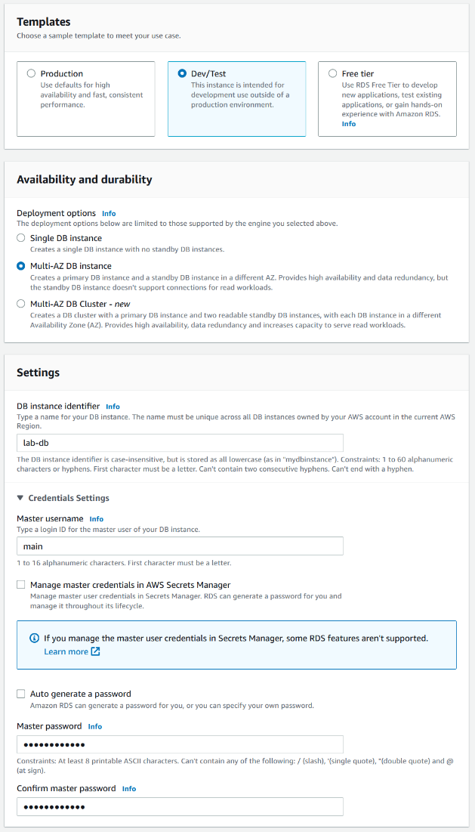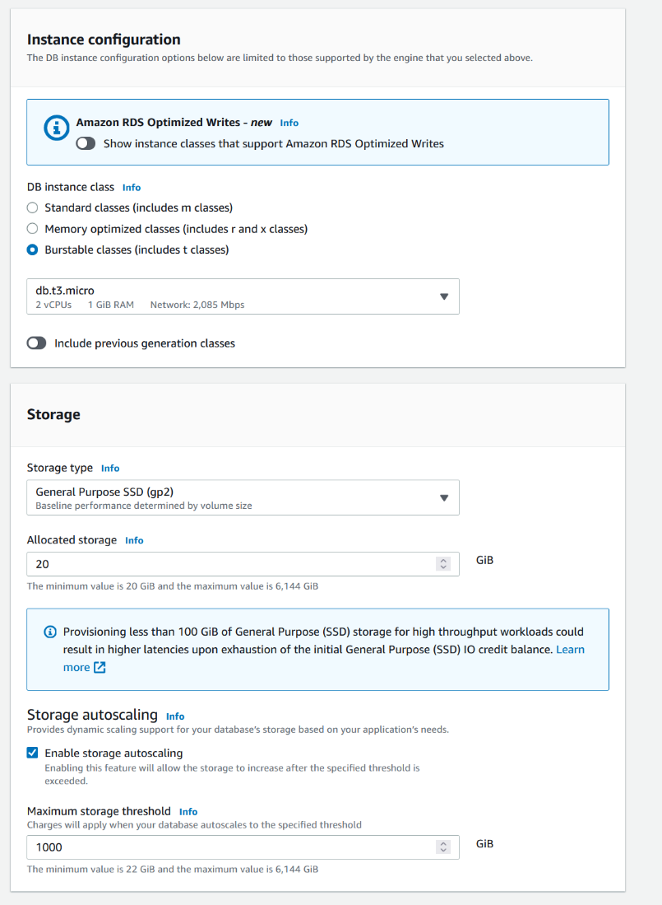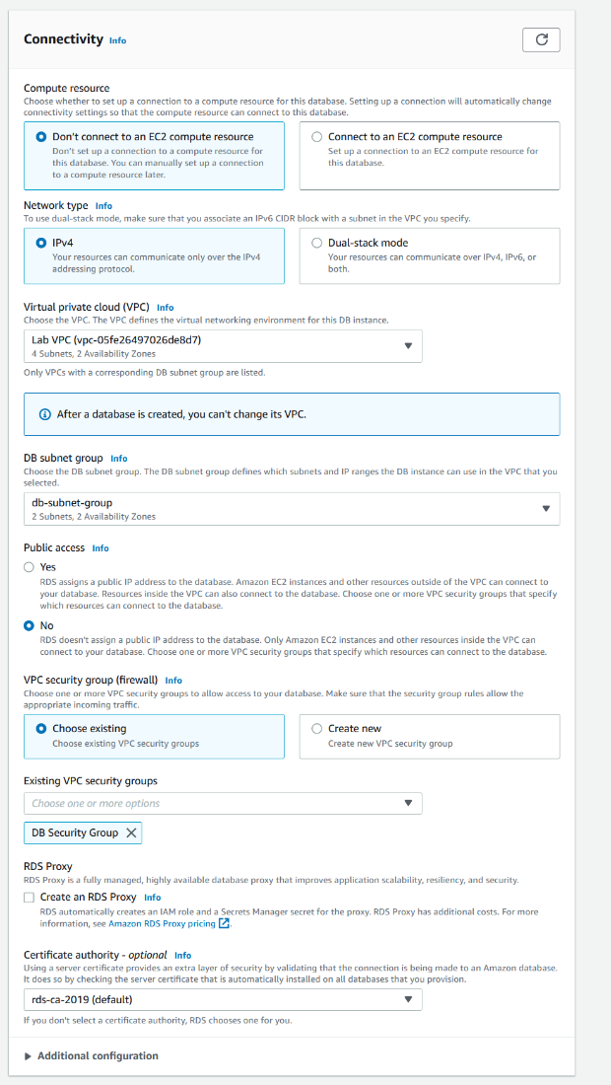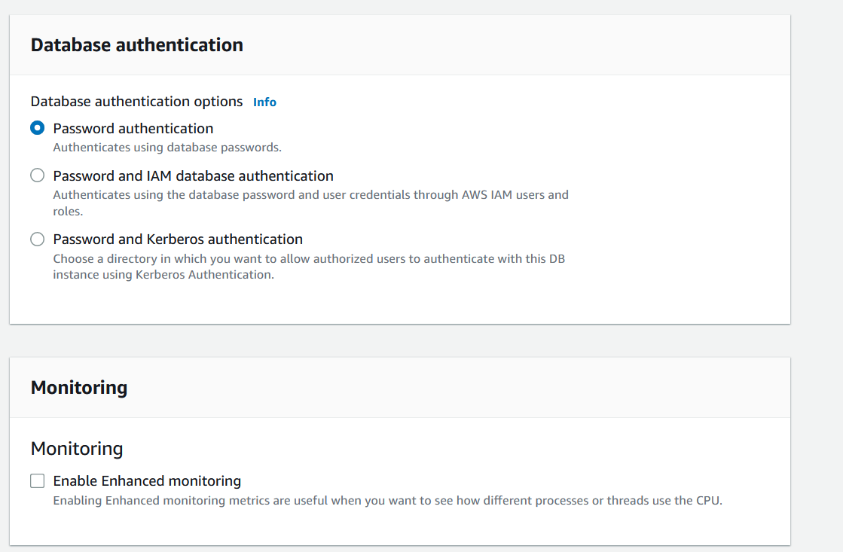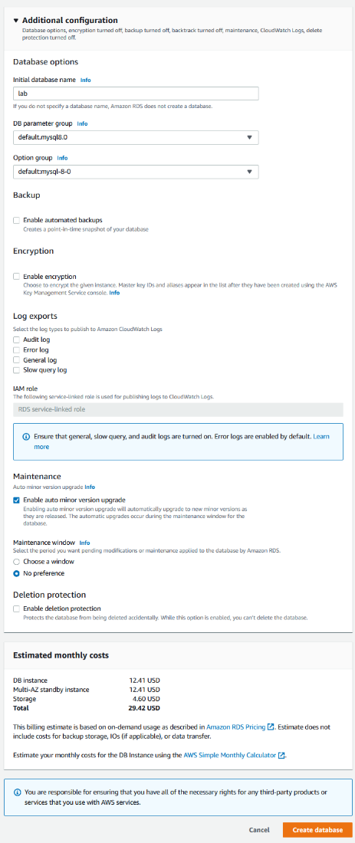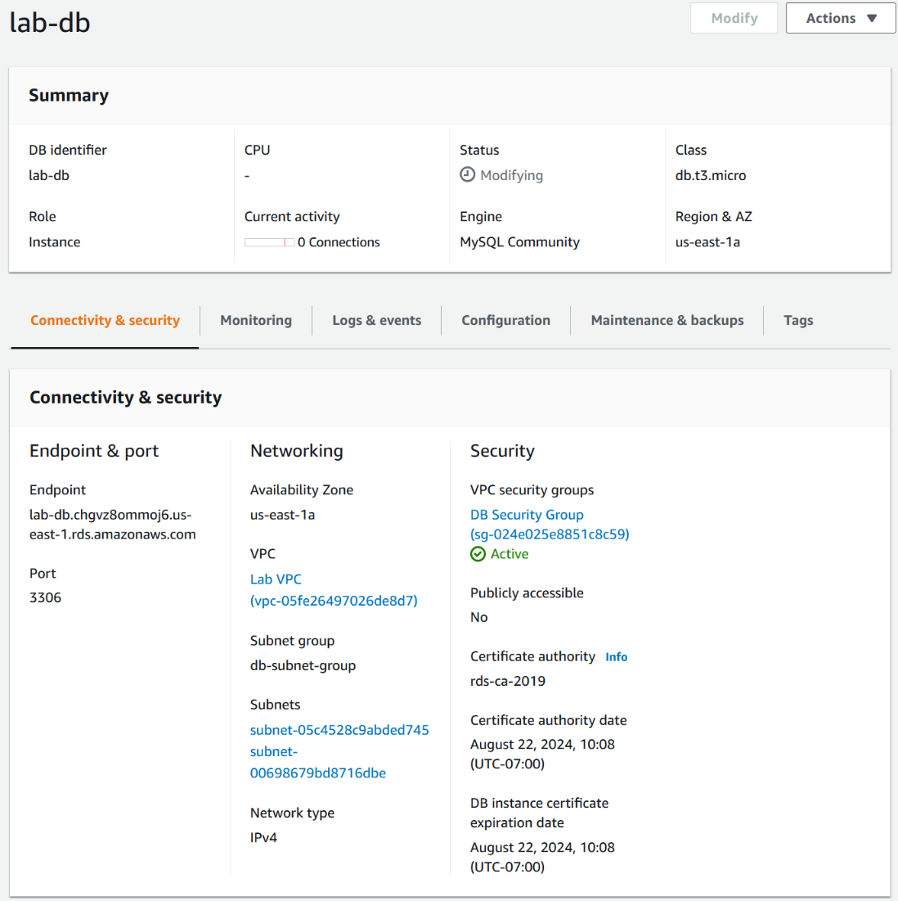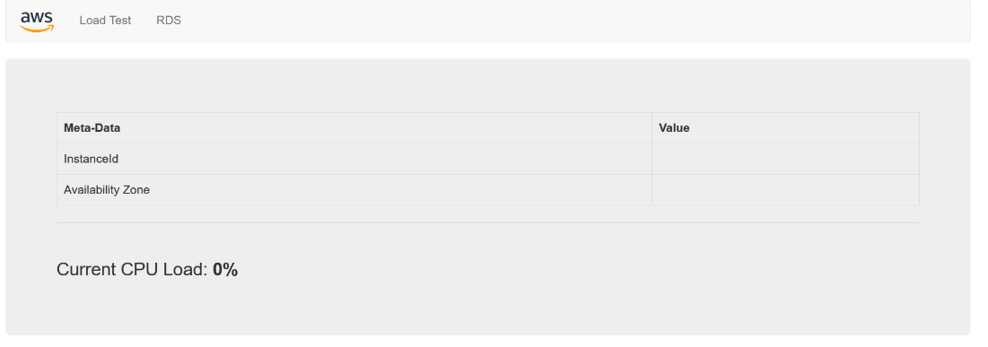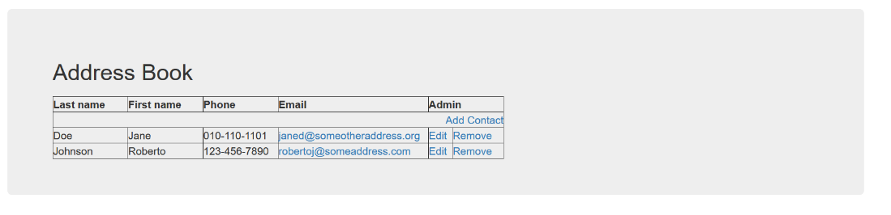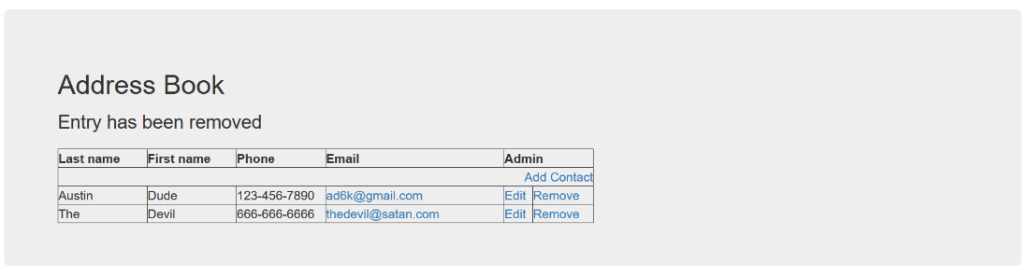

Lab 6

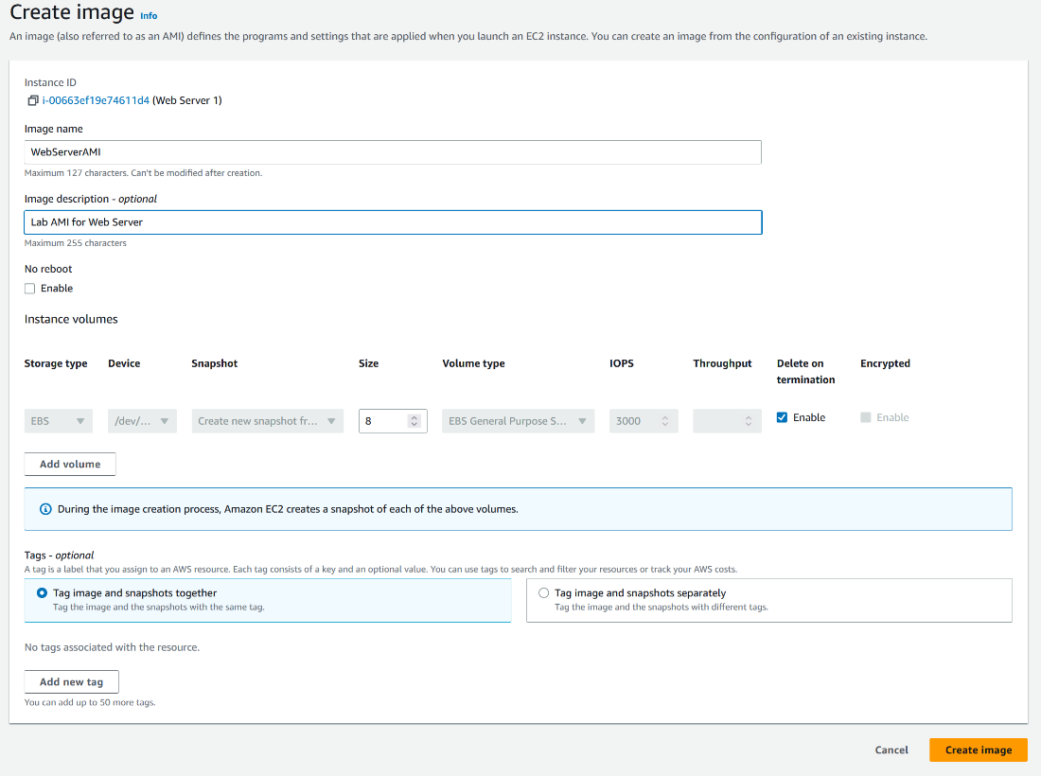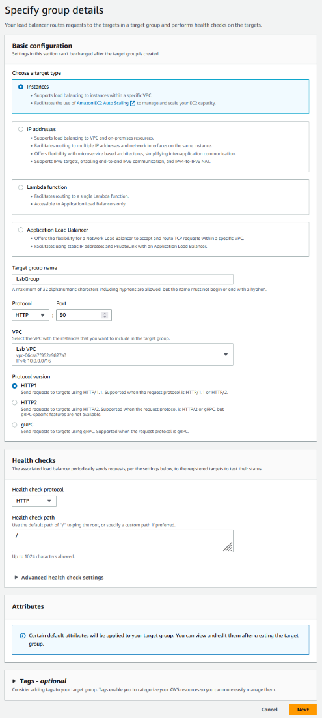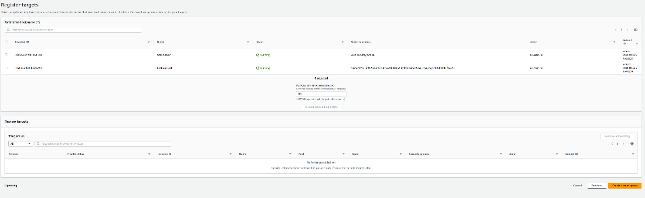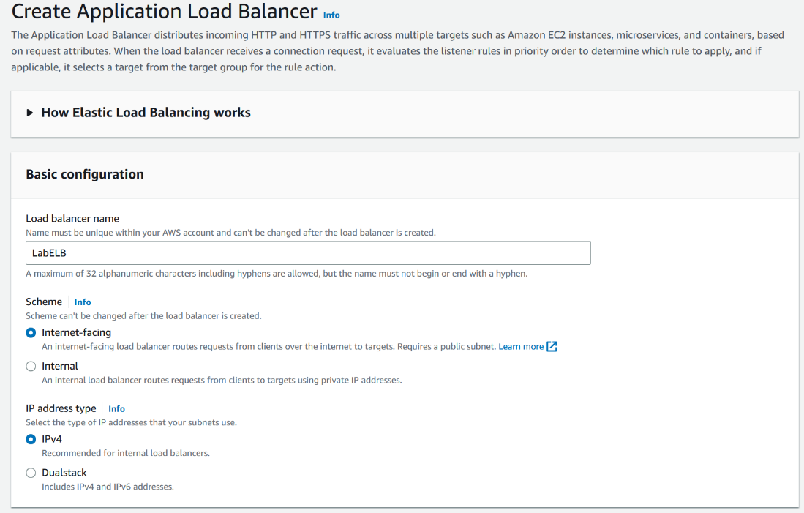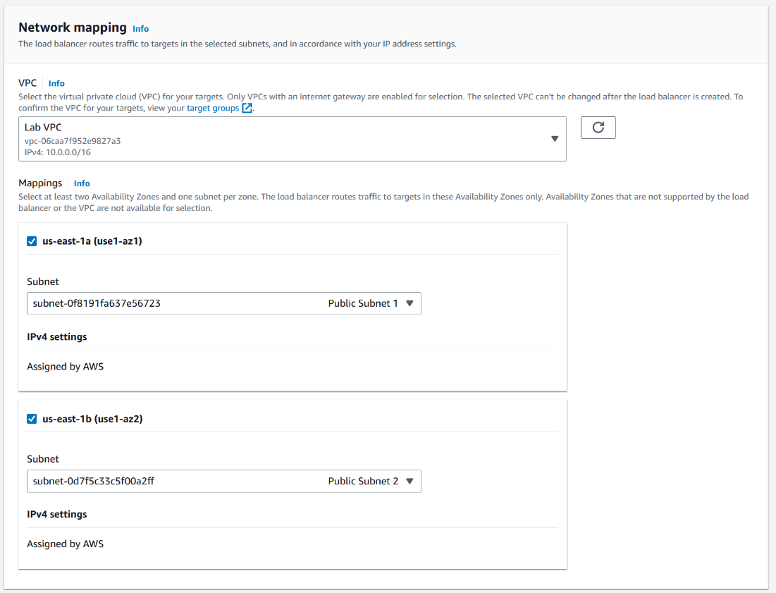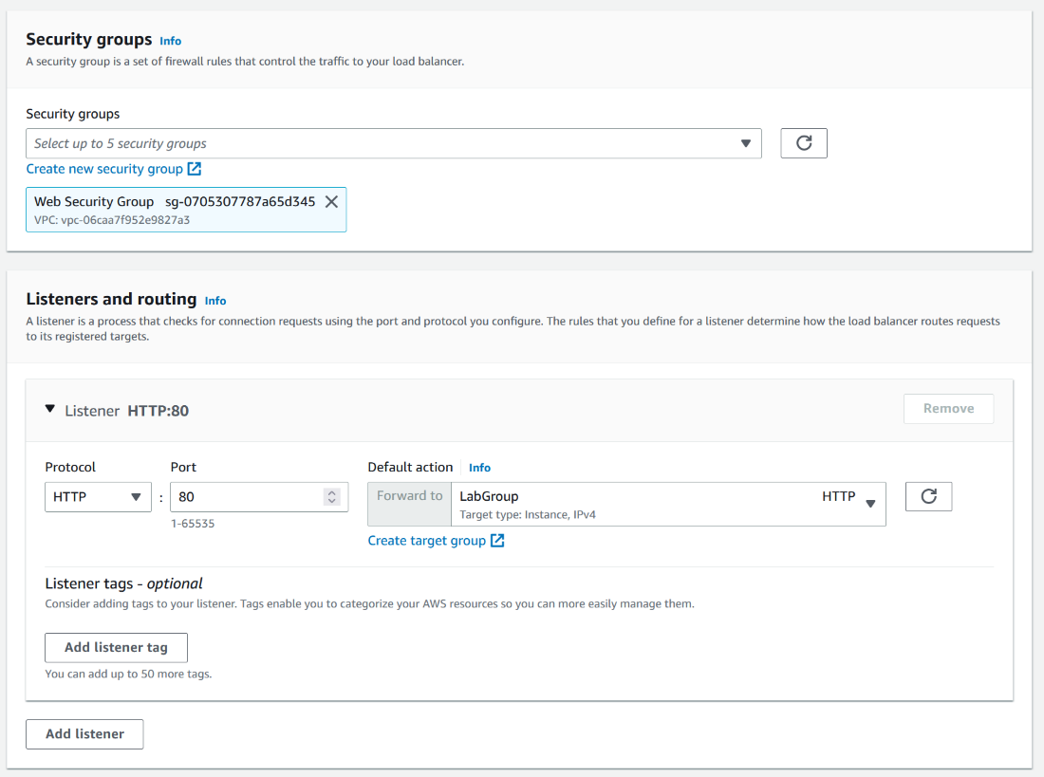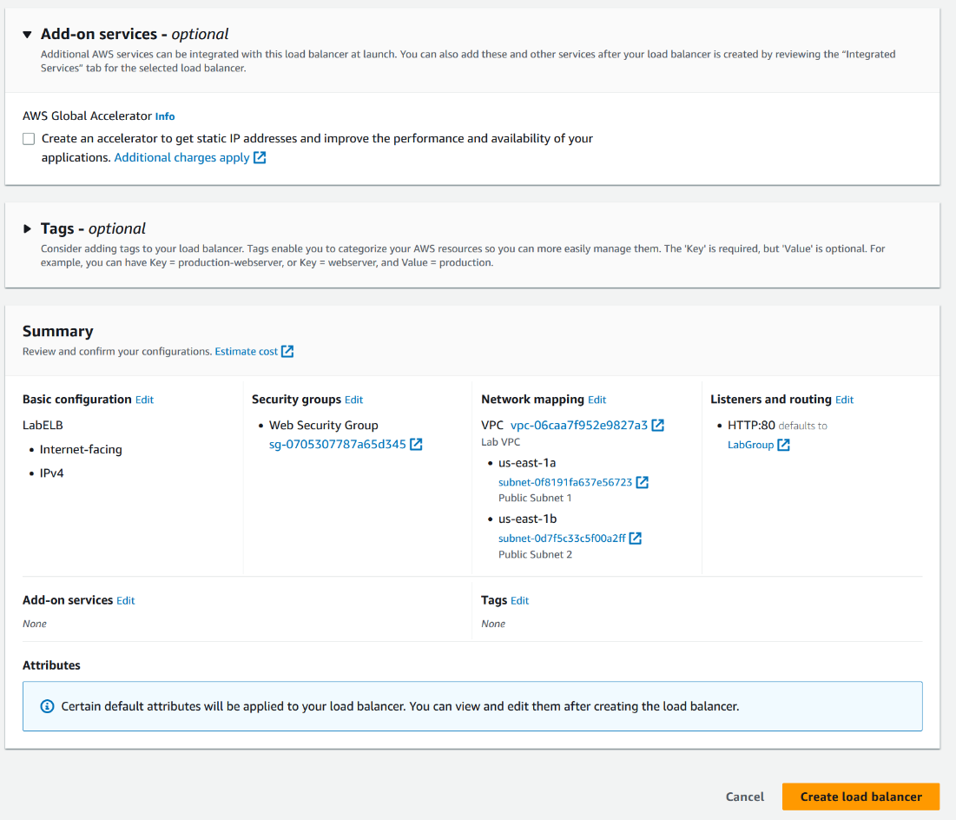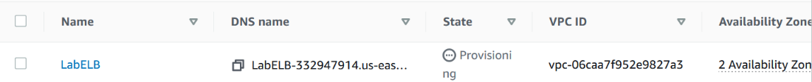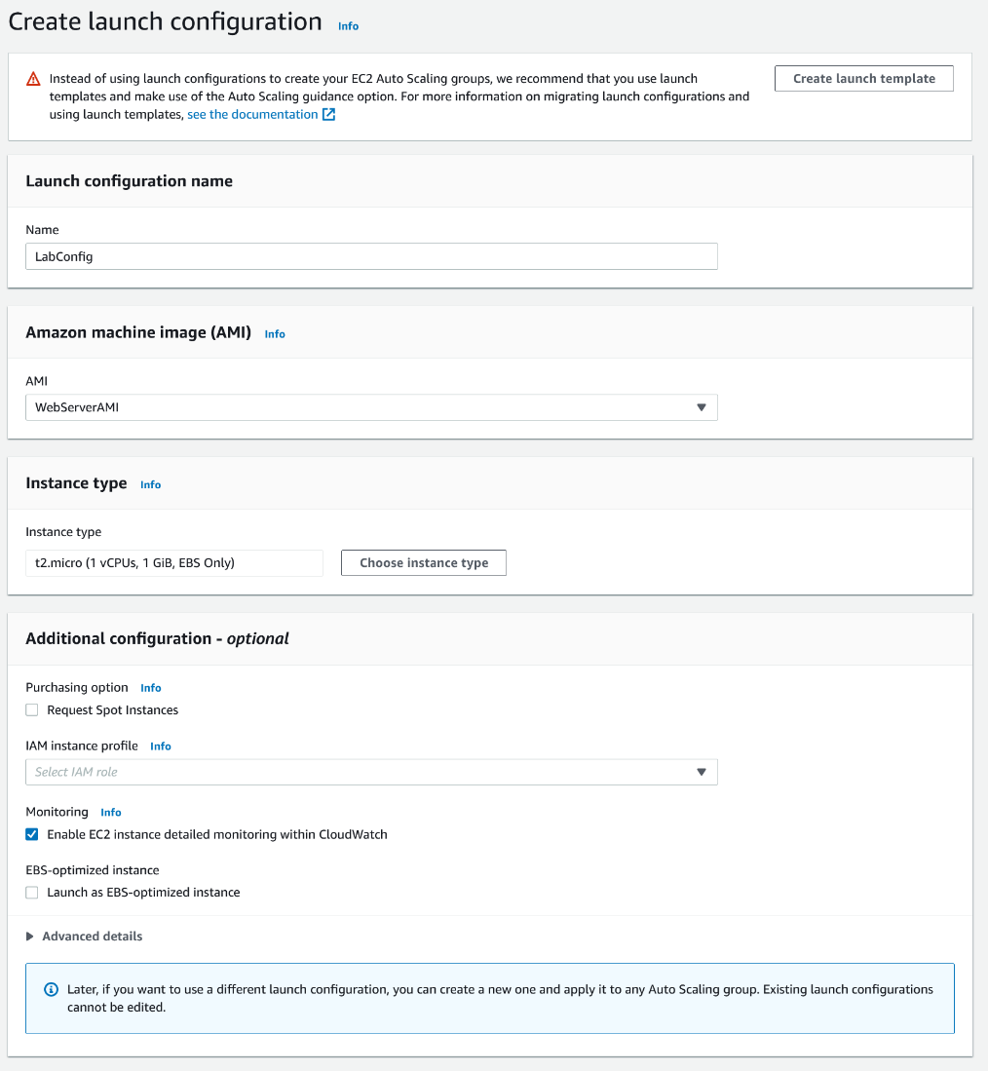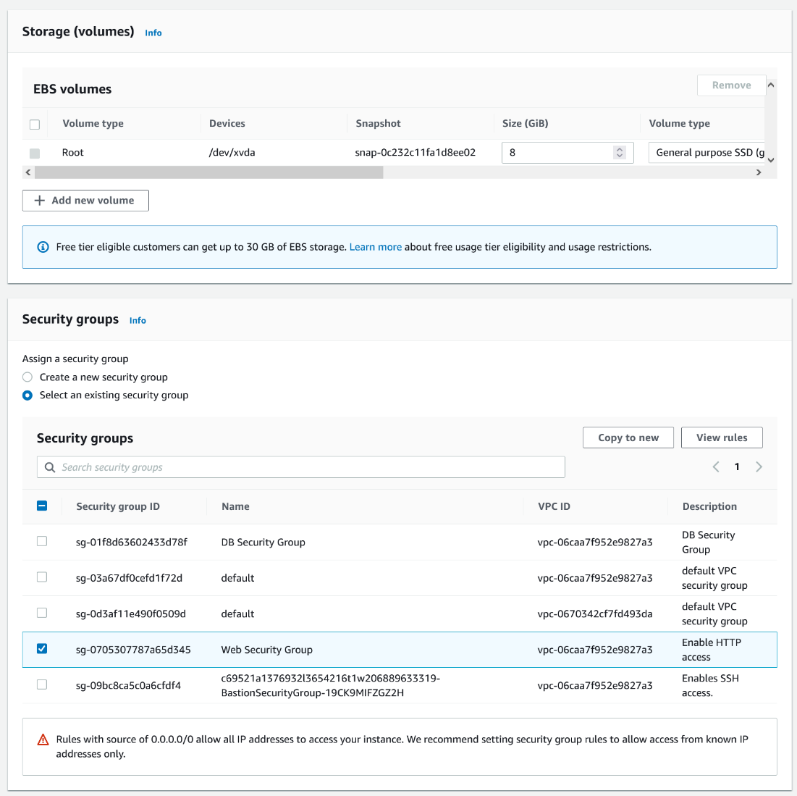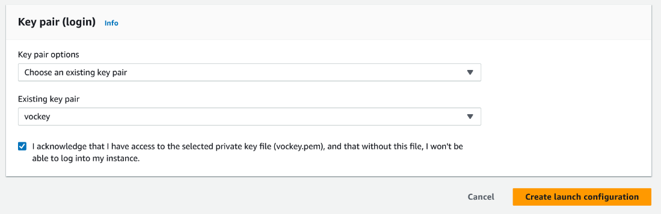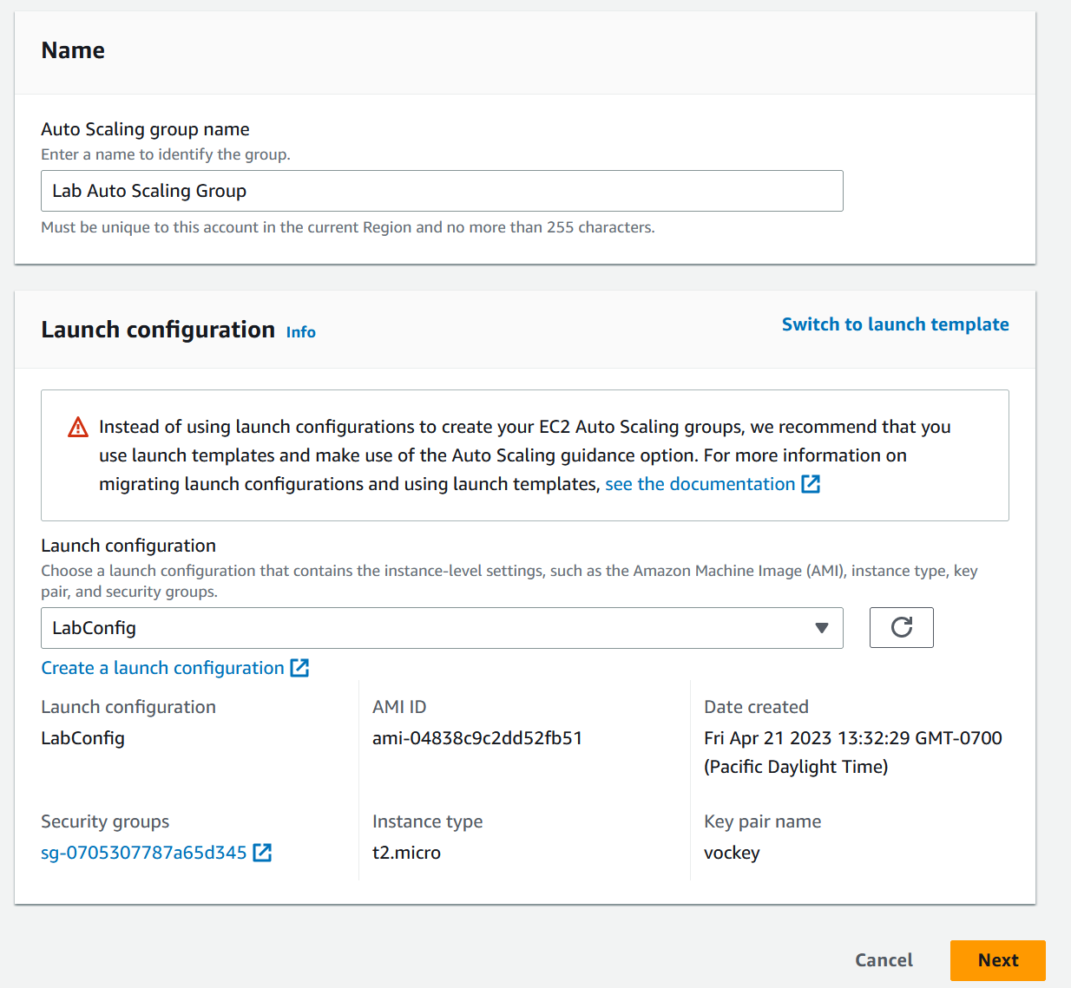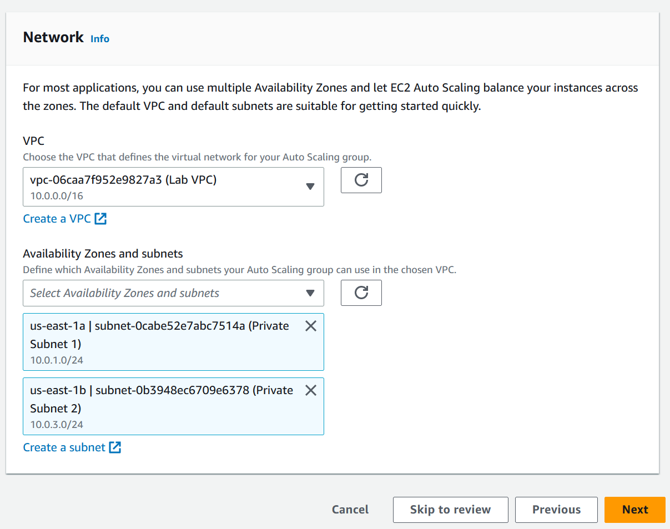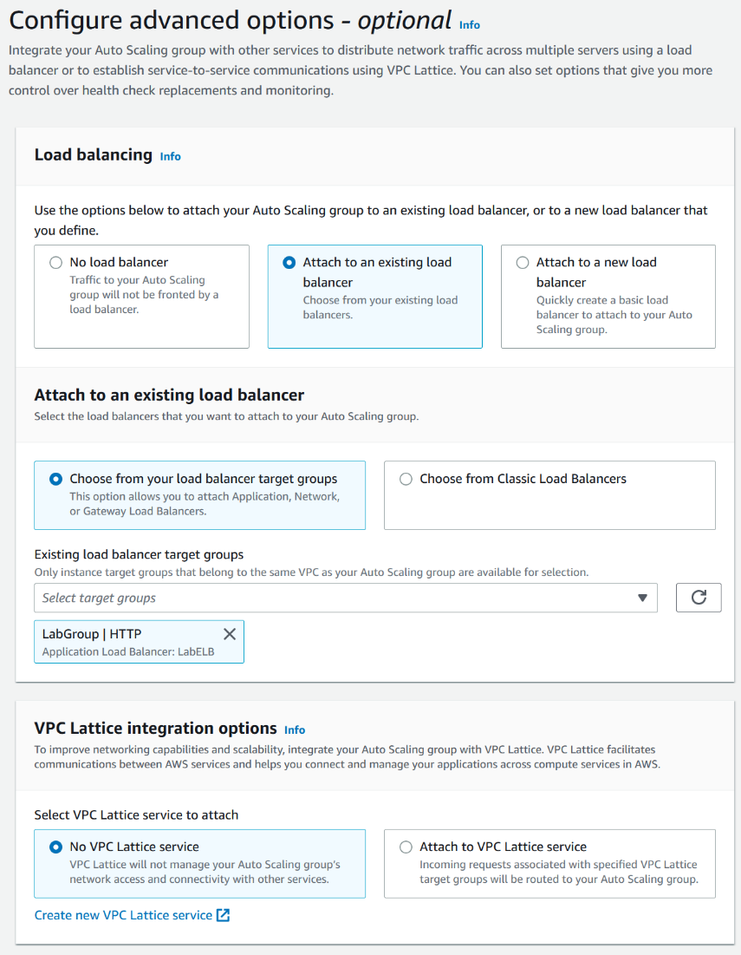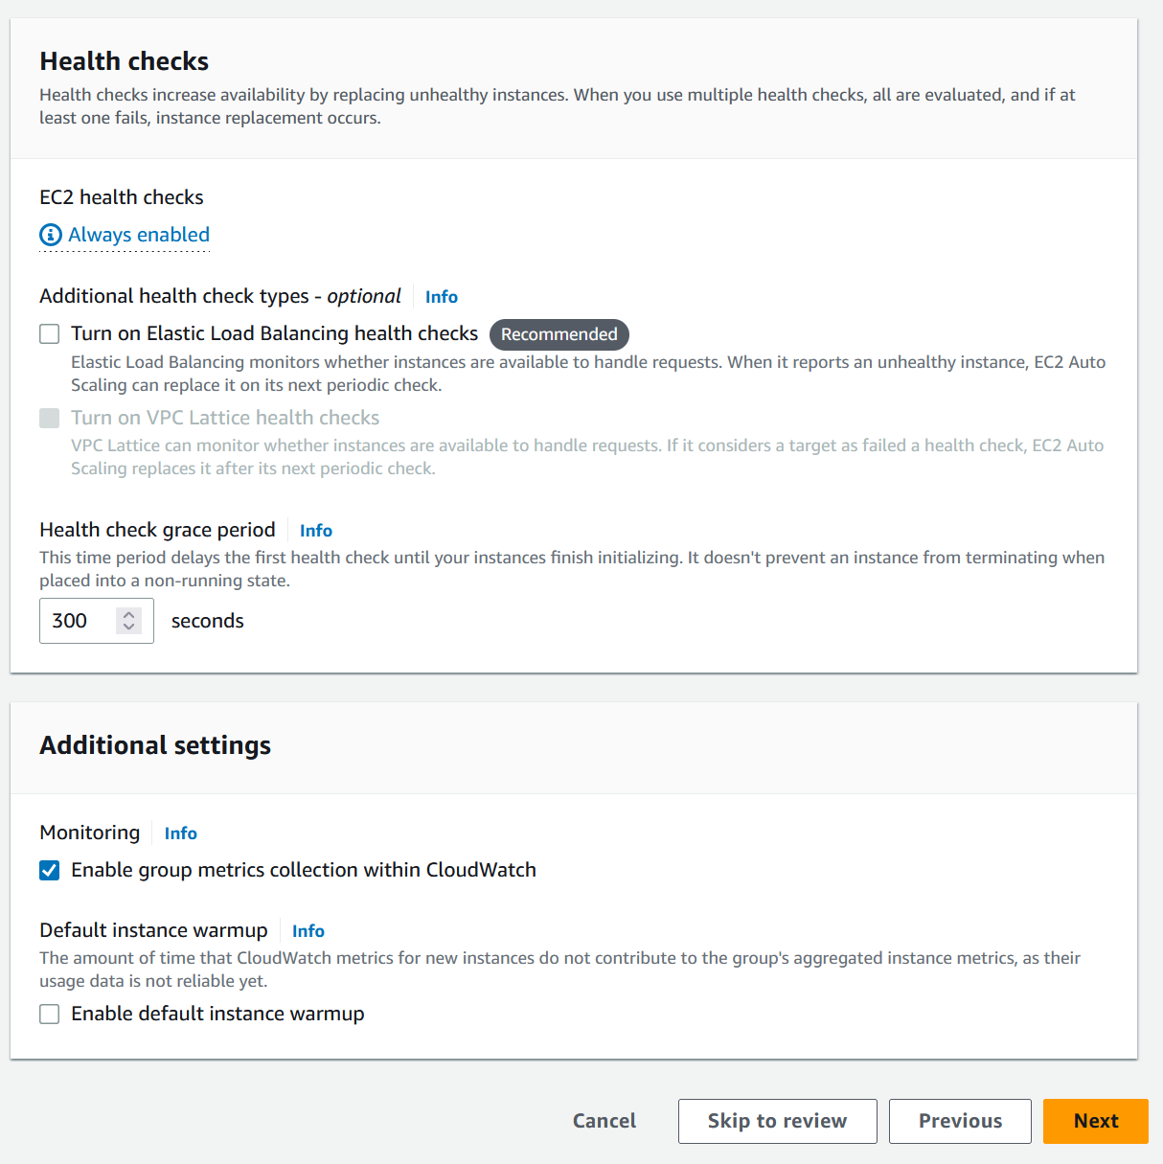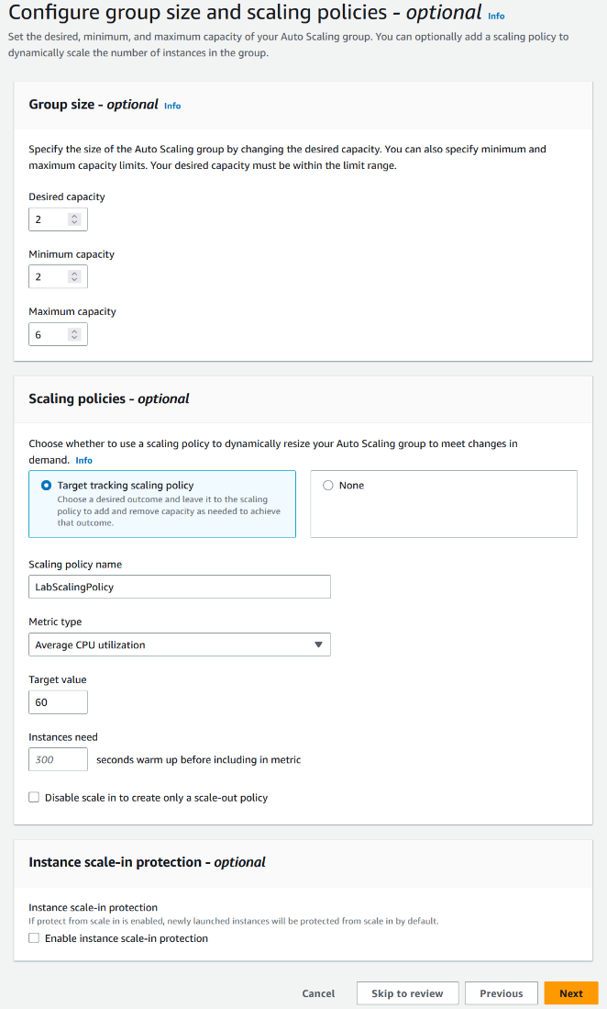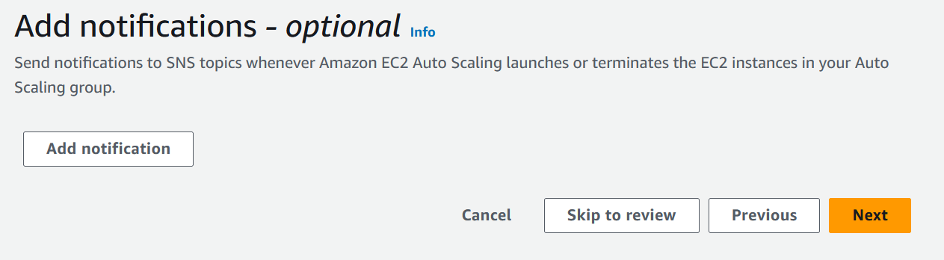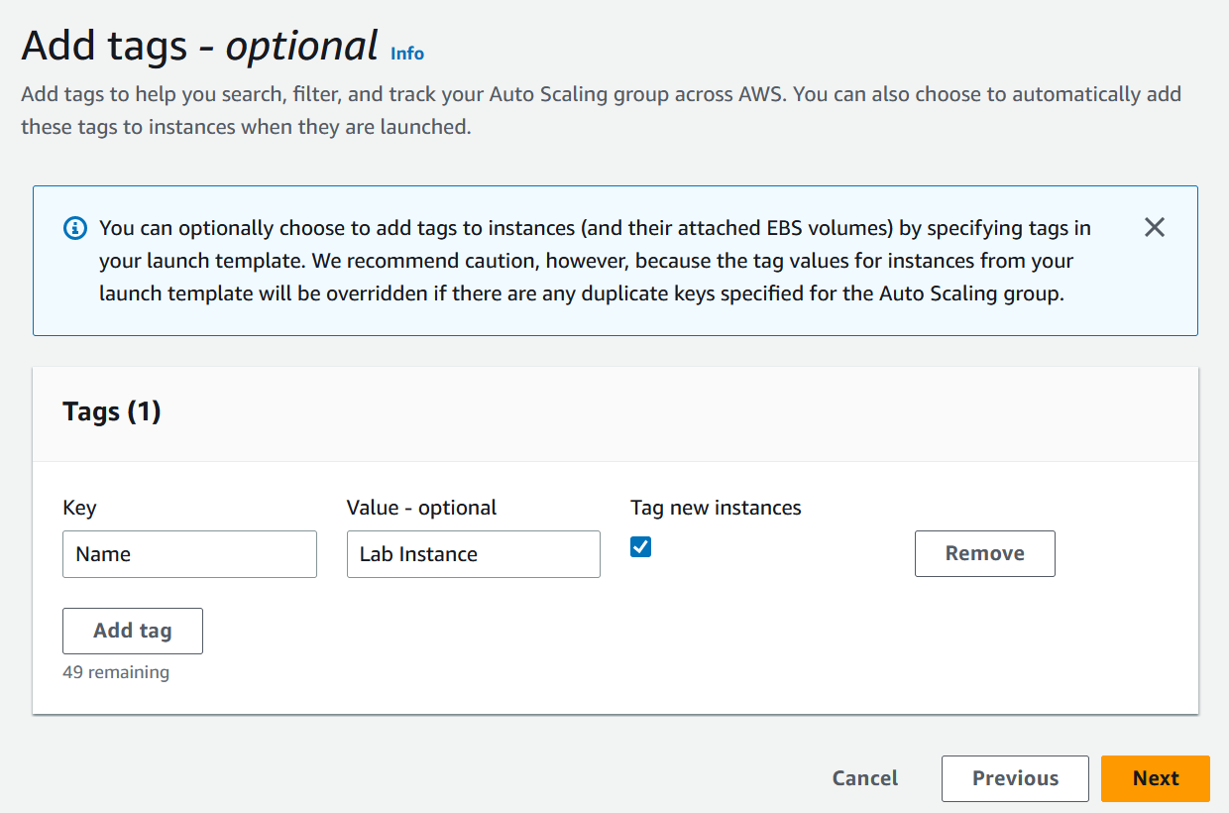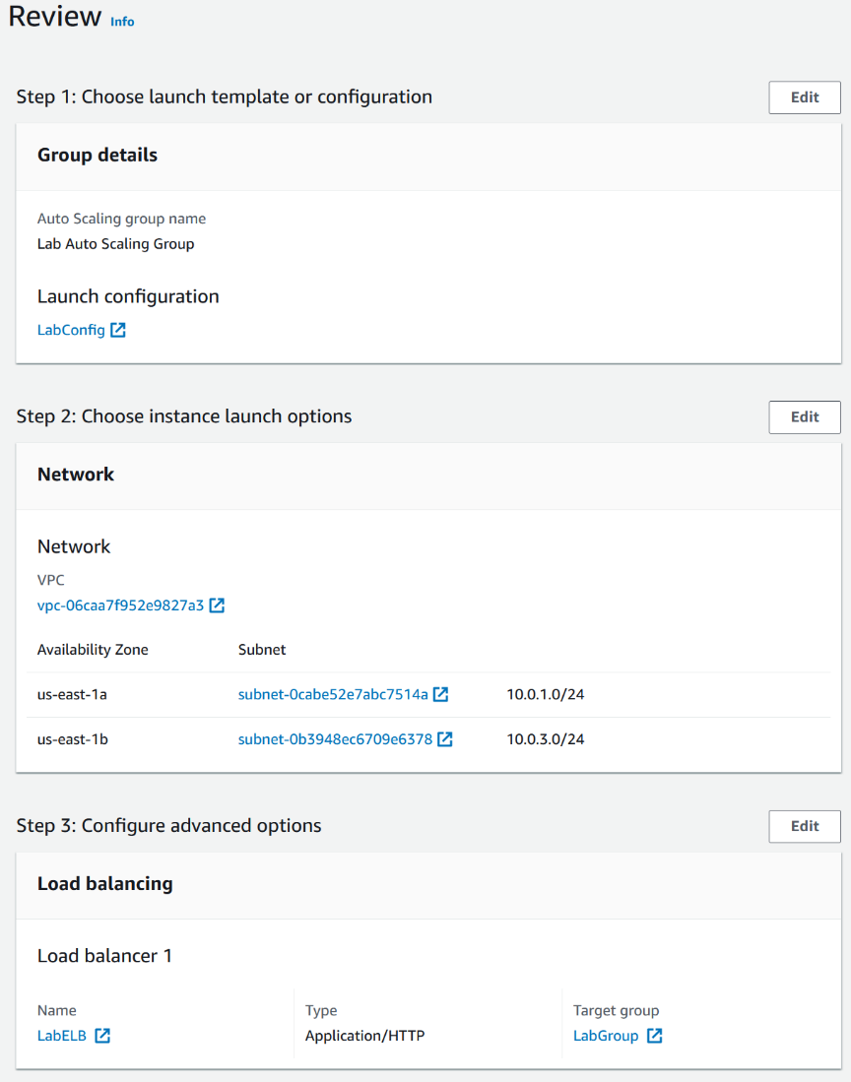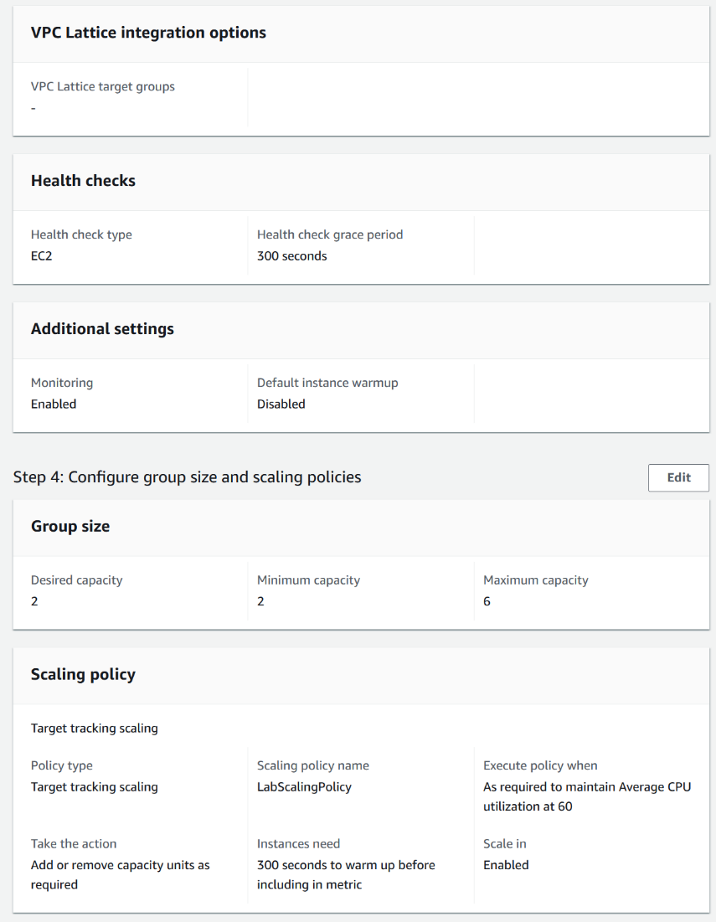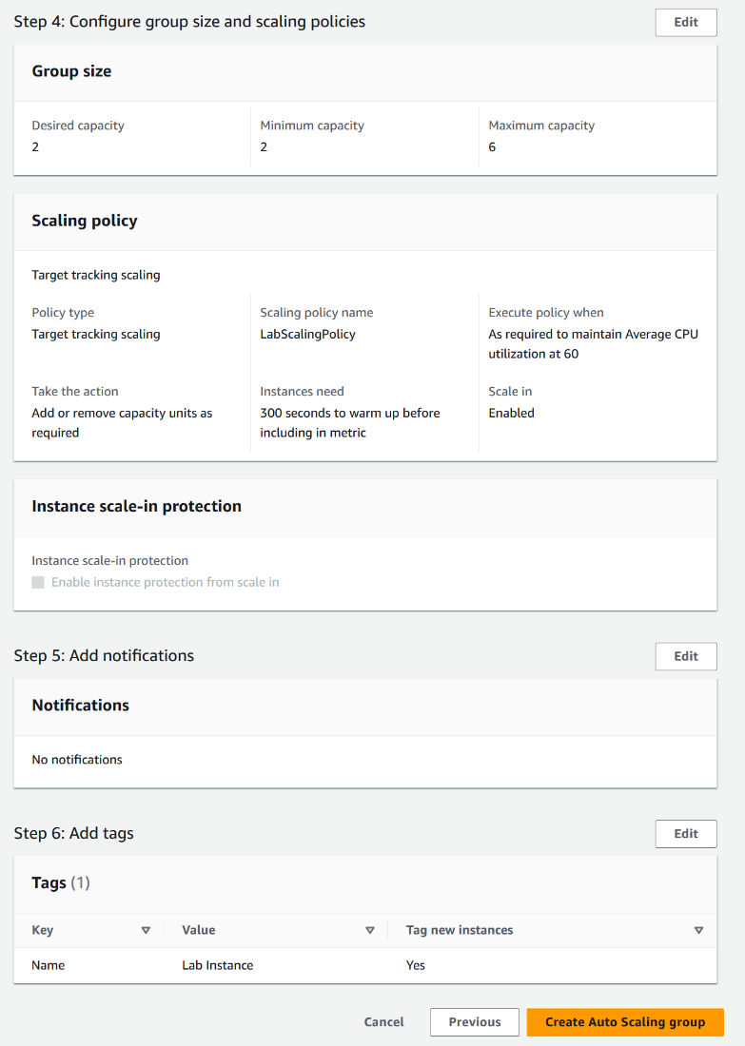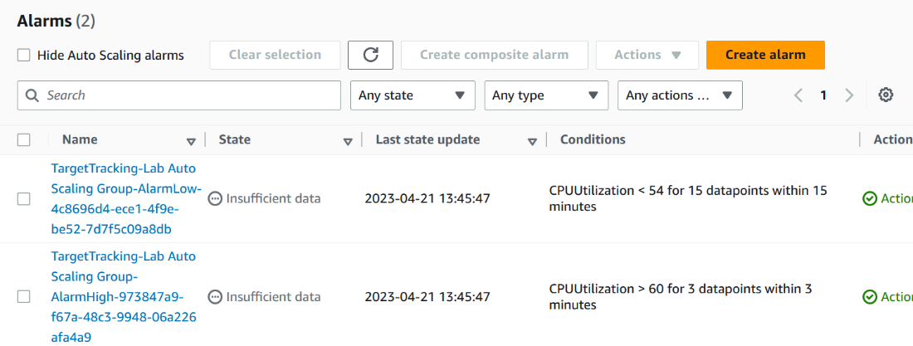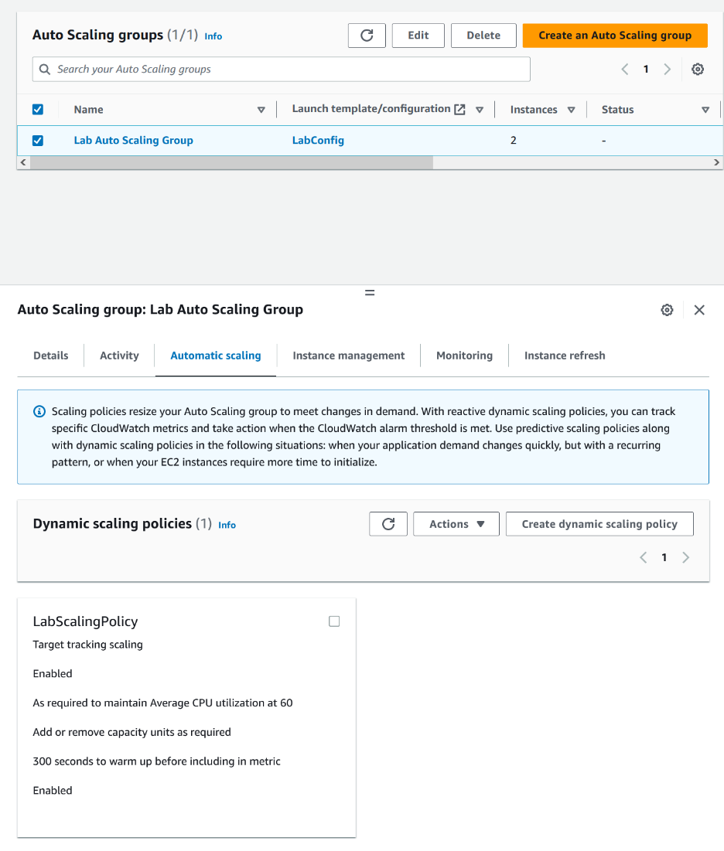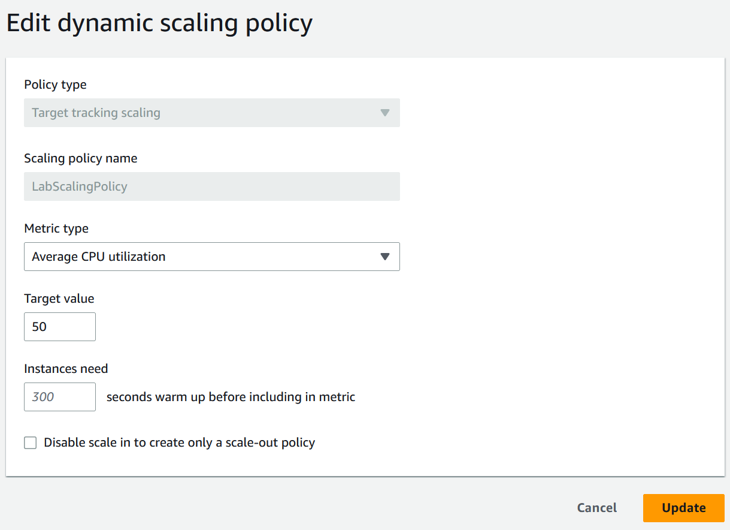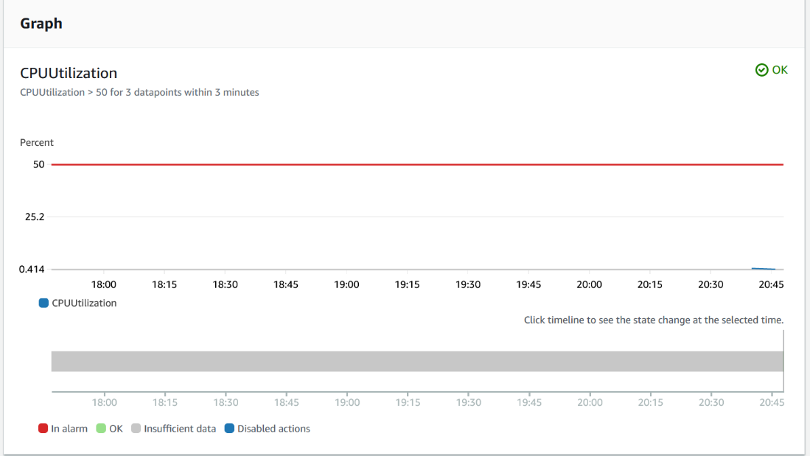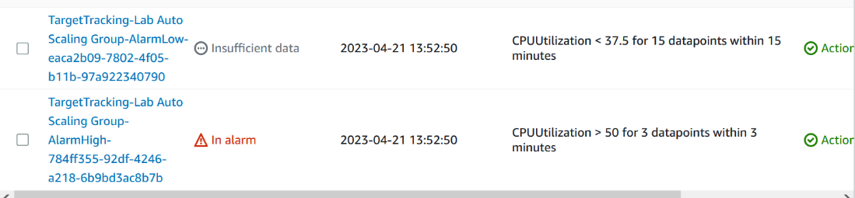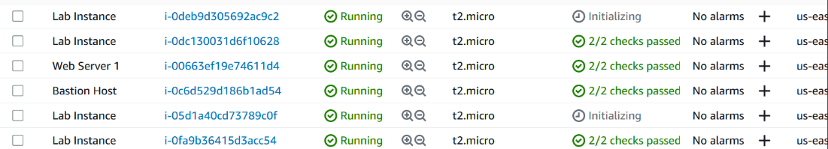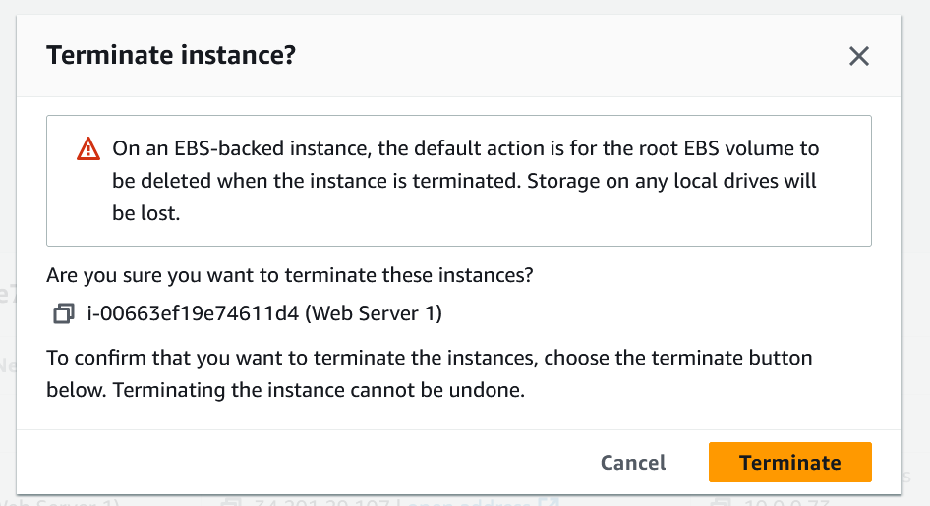

Unlike the last 3 labs, I didn’t have many problems. Everything I did was just follow the given instructions to the letter. This time, I made sure to read the instructions very carefully, so that I wouldn’t have to get stuck for an hour to fix one thing. This meant I had almost no problems with the labs. The hardest part was trying to find where all the things were, so I found everything using Ctrl + F. However, I still didn't take any of the screenshots needed for the lab, so like the last one, I had to go back and do every lab again for the screenshots. However, I have them all now and I don’t need to worry about it anymore.

In conclusion, I learned about AWS, how it works, and its advantages and disadvantages compared to traditional server rooms. I learned how to set up parts of AWS and get different parts to interact with one another. I did run into some issues, but they were all very minor and were a result of still not reading the instructions perfectly. Overall, I learned a lot about how to set up all the given devices and how they work together, which was fun to complete.